Lab - Use NETCONF to Access an IOS XE Device
Name: Dawn Andrei Pamesa
Course and Section: CS0016 (NetComms 2), TS31-9
Activity: Lab Exercise 7.2 - Use NETCONF to Access an IOS XE Device
Date: November 10, 2026

Objectives
Part 1: Build the Network and Verify Connectivity
Part 2: Use a NETCONF Session to Gather Information
Part 3: Use ncclient to Connect to NETCONF
Part 4: Use ncclient to Retrieve the Configuration
Part 5: Use ncclient to Configure a Device
Part 6: Challenge: Modify the Program Used in This Lab

Background / Scenario
The Network Configuration Protocol (NETCONF), defined in RFCs 4741 and 6241, uses YANG data models to communicate with various devices on the network. YANG (yet another next generation) is a data modeling language. This language defines the data that is sent over network management protocols, like NETCONF. When using NETCONF to access an IOS XE device, the data is returned in XML format.
In this lab, you will use a NETCONF client, ncclient, which is a Python module for client-side scripting. You will use ncclient to verify NETCONF is configured, retrieve a device configuration, and modify a device configuration.

Required Resources
- 1 PC with operating system of your choice
- Virtual Box or VMWare
- DEVASC Virtual Machine
- CSR1kv Virtual Machine

Instructions

Launch the VMs and Verify Connectivity
In this Part, you launch the two VMs and verify connectivity. You will then establish a secure shell (SSH) connection.

Launch the VMs
If you have not already completed the Lab - Install the Virtual Machine Lab Environment and the Lab - Install the CSR1kv VM, do so now. If you have already completed these labs, launch both the DEVASC VM and CSR1000v VM now.

Verify connectivity between the VMs.
      - In the CSR1kv VM, press Enter to get a command prompt and then use show ip interface brief to verify that the IPv4 address is 192.168.56.101. If the address is different, make a note of it.
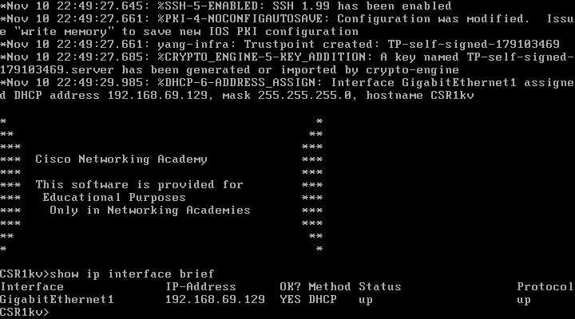
Screenshot 1: The CSR1kv console, where GigabitEthernet1 got the DHCP address 192.168.69.129. This address replaces the 192.168.56.101 in the sheet in every step below, since both VMs run on VMware.
      - Open a terminal in VS Code in the DEVASC VM.
      - Ping the CSR1kv to verify connectivity. You should have already done this previously in the installation labs. If you are not able to ping, then revisit those labs listed above in Part 1a.
devasc@labvm:~$ ping -c 5 192.168.56.101
PING 192.168.56.101 (192.168.56.101) 56(84) bytes of data.
64 bytes from 192.168.56.101: icmp_seq=1 ttl=254 time=1.37 ms
64 bytes from 192.168.56.101: icmp_seq=2 ttl=254 time=1.15 ms
64 bytes from 192.168.56.101: icmp_seq=3 ttl=254 time=0.981 ms
64 bytes from 192.168.56.101: icmp_seq=4 ttl=254 time=1.01 ms
64 bytes from 192.168.56.101: icmp_seq=5 ttl=254 time=1.14 ms

--- 192.168.56.101 ping statistics ---
5 packets transmitted, 5 received, 0% packet loss, time 4006ms
rtt min/avg/max/mdev = 0.981/1.130/1.365/0.135 ms
devasc@labvm:~$
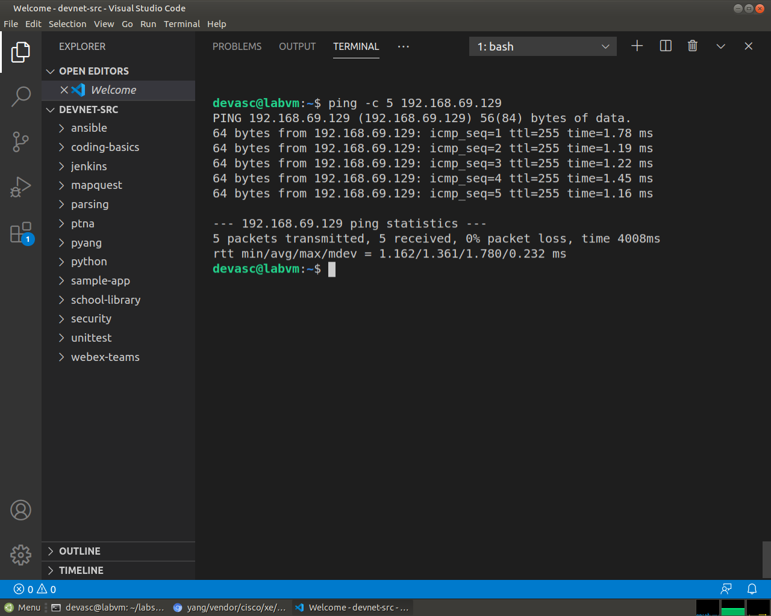
Screenshot 2: Ping from the DEVASC VM to the CSR1kv, with 5 packets sent and 5 received, which means 0% packet loss.

Verify SSH connectivity to the CSR1kv VM.
      - In the terminal for the DEVASC VM, SSH to the CSR1kv VM with the following command:
devasc@labvm:~$ ssh cisco@192.168.56.101
Note: The first time you SSH to the CSR1kv, your DEVASC VM warns you about the authenticity of the CSR1kv. Because you trust the CSR1kv, answer yes to the prompt.
The authenticity of host '192.168.56.101 (192.168.56.101)' can't be established.
RSA key fingerprint is SHA256:HYv9K5Biw7PFiXeoCDO/LTqs3EfZKBuJdiPo34VXDUY.
Are you sure you want to continue connecting (yes/no/[fingerprint])? yes
Warning: Permanently added '192.168.56.101' (RSA) to the list of known hosts.
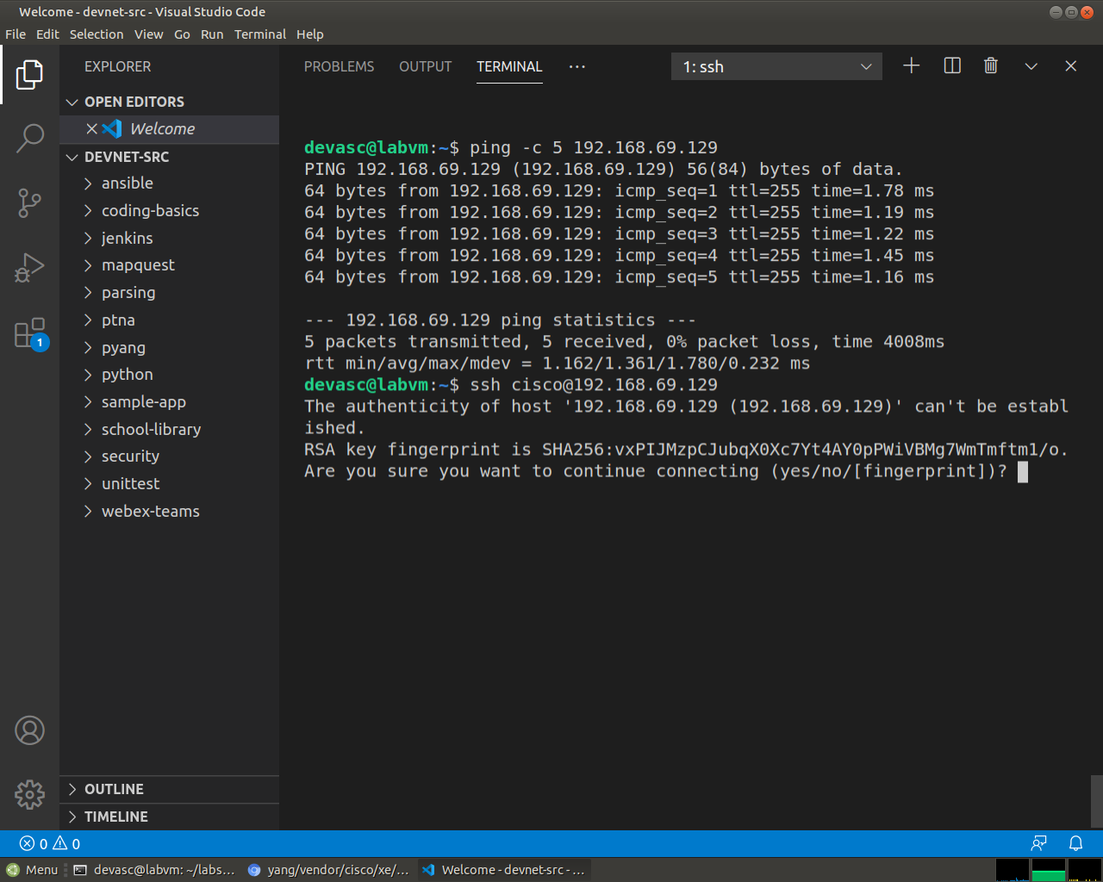
Screenshot 3: The first SSH connection asks to trust the router's RSA key, so the answer is yes.
      - Enter cisco123! as the password and you should now be at the privileged EXEC command prompt for the CSR1kv.
Password:

CSR1kv#
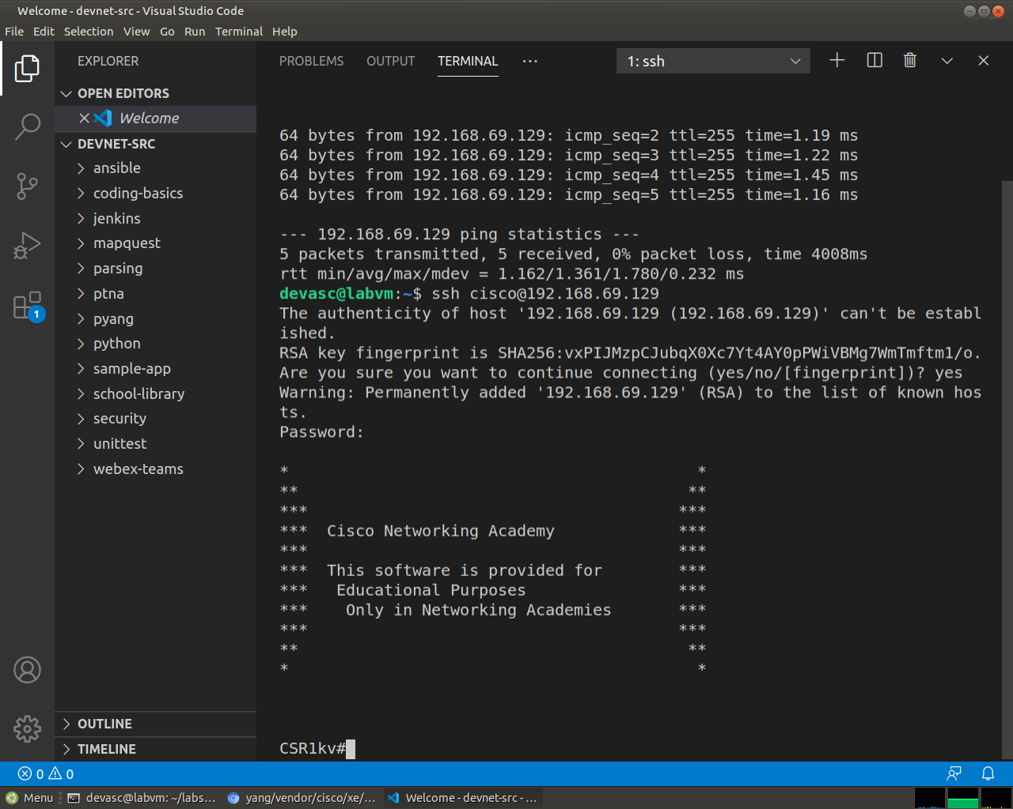
Screenshot 4: After the password, the SSH session lands on the CSR1kv# prompt.
      - Leave the SSH session open for the next Part.

Use a NETCONF Session to Gather Information
In this Part, you will verify that NETCONF is running, enable NETCONF if it is not, and verify that NETCONF is ready for an SSH connection. YSou will then connect to the NETCONF process, start a NETCONF session, gather interface information, and close the session.

Check if NETCONF is running on the CSR1kv.
      - NETCONF may already be running if another student enabled it, or if a later IOS version enables it by default. From your SSH session with the CSR1kv, use the show platform software yang-management process command to see if the NETCONF SSH daemon (ncsshd) is running.
CSR1kv# show platform software yang-management process
confd : Running
nesd : Running
syncfd : Running
ncsshd : Running
dmiauthd : Running
nginx : Running
ndbmand : Running
pubd : Running

CSR1kv#
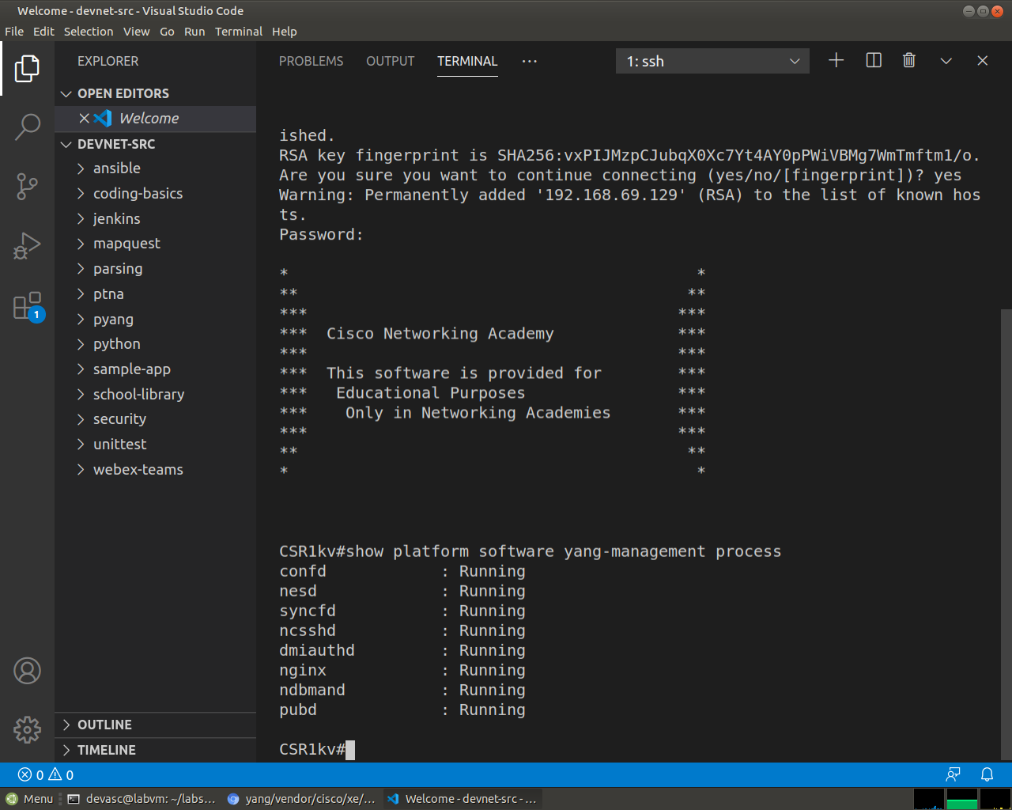
Screenshot 5: show platform software yang-management process, where confd, nesd, syncfd, ncsshd and the other processes are all Running, so NETCONF does not need to be enabled.
      - If NETCONF is not running, as shown in the output above, enter the global configuration command netconf-yang.
CSR1kv# config t
CSR1kv (config)# netconf-yang
      - Type exit to close the SSH session.

Access the NETCONF process through an SSH terminal.
In this step, you will re-establish an SSH session with the CSR1kv. But this time, you will specify the NETCONF port 830 and send netconf as a subsystem command.
Note: For more information on these options, explore the manual pages for SSH (man ssh).
      - Enter the following command in a terminal window. You can use the up arrow to recall the latest SSH command and just add the -p and -s options as shown. Then, enter cisco123! as the password.
devasc@labvm:~$ ssh cisco@192.168.56.101 -p 830 -s netconf
cisco@192.168.56.101's password:
      - The CSR1kv will respond with a hello message that includes over 400 lines of output listing all of its NETCONF capabilities. The end of NETCONF messages are identified with ]]>]]>.
<?xml version="1.0" encoding="UTF-8"?>
<hello xmlns="urn:ietf:params:xml:ns:netconf:base:1.0">
<capabilities>
<capability>urn:ietf:params:netconf:base:1.0</capability>
<capability>urn:ietf:params:netconf:base:1.1</capability>
<capability>urn:ietf:params:netconf:capability:writable-running:1.0</capability>
<capability>urn:ietf:params:netconf:capability:xpath:1.0</capability>
<capability>urn:ietf:params:netconf:capability:validate:1.0</capability>
<capability>urn:ietf:params:netconf:capability:validate:1.1</capability>
(output omitted)
</capability>
</capabilities>
<session-id>20</session-id></hello>]]>]]>
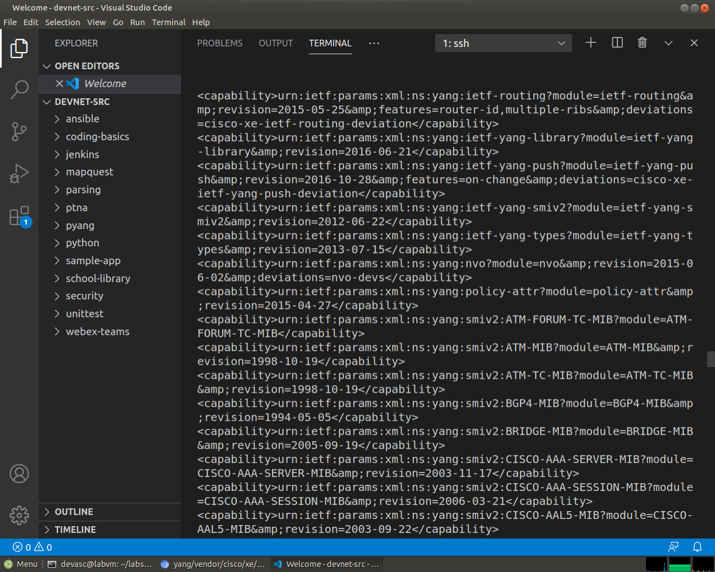
Screenshot 6: A middle part of the hello message from the router, which lists its NETCONF capabilities.
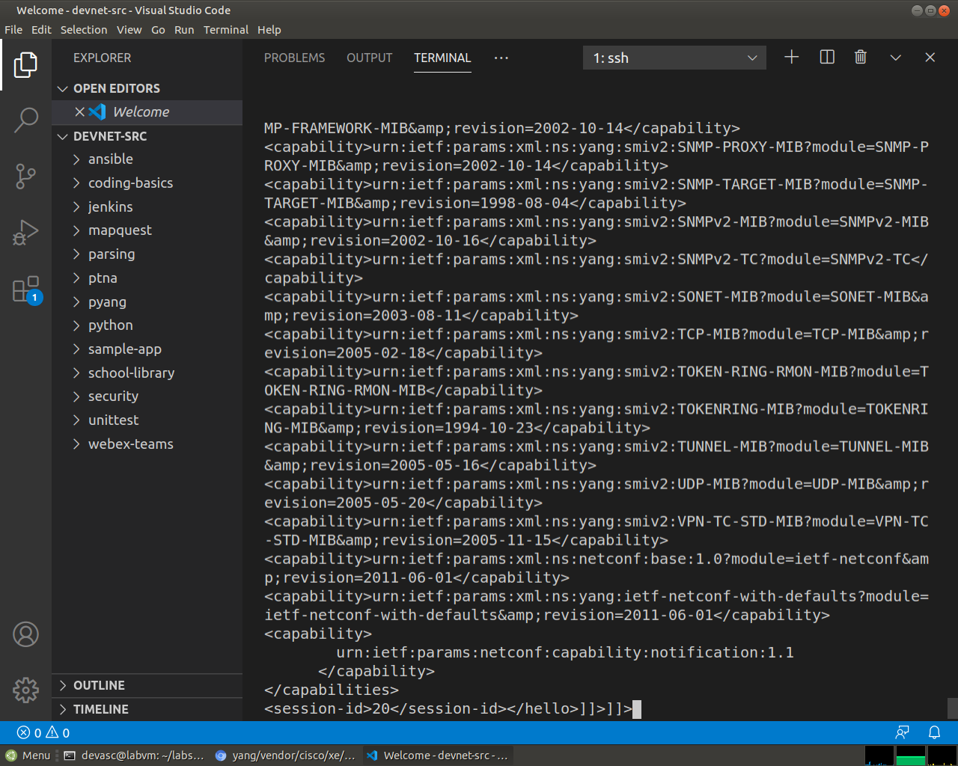
Screenshot 7: The end of the hello message, closing with session-id 20 and the ]]>]]> marker.

Start a NETCONF session by sending a hello message from the client.
To start a NETCONF session, the client needs to send its own hello message. The hello message should include the NETCONF base capabilities version the client wants to use.
      - Copy and paste the following XML code into the SSH session. Notice that the end of the client hello message is identified with a ]]>]]>.
<hello xmlns="urn:ietf:params:xml:ns:netconf:base:1.0">
<capabilities>
<capability>urn:ietf:params:netconf:base:1.0</capability>
</capabilities>
</hello>
]]>]]>
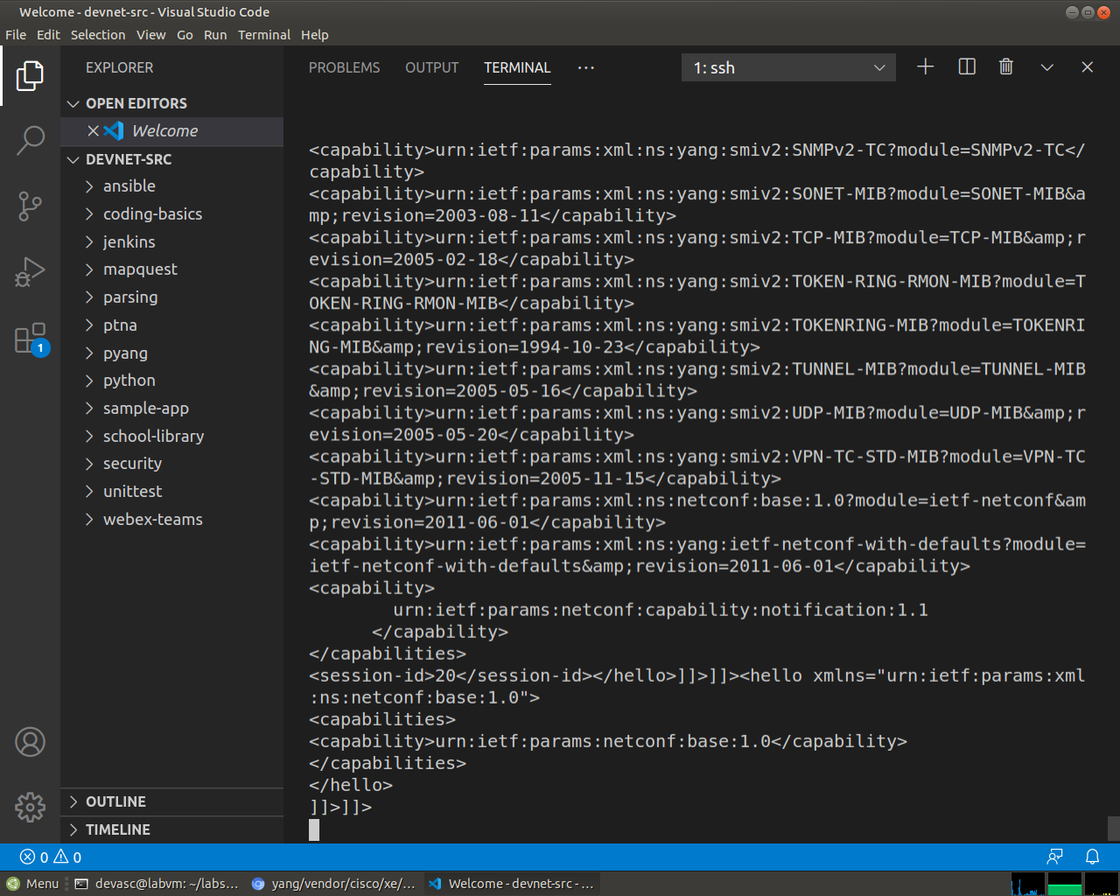
Screenshot 8: The client hello pasted into the same session, using only the base:1.0 capability.
      - Switch to the CSR1kv VM and use the show netconf-yang sessions command to verify that a NETCONF session has been started. If the CSR1kv VM screen is dark, press Enter to wake it up.
Open configuration window
CSR1kv> en
CSRk1v# show netconf-yang sessions
R: Global-lock on running datastore
C: Global-lock on candidate datastore
S: Global-lock on startup datastore

Number of sessions : 1

session-id transport username source-host global-lock
-------------------------------------------------------------------------------
20 netconf-ssh cisco 192.168.56.1 None

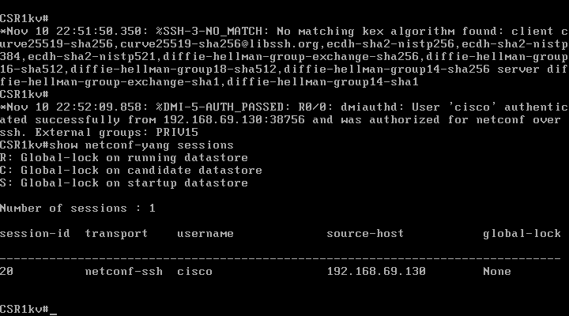
Screenshot 9: On the CSR1kv console, show netconf-yang sessions lists one session: session-id 20, user cisco, from 192.168.69.130 (the DEVASC VM).
CSR1kv#
Close configuration window

Send RPC messages to an IOS XE device.
During an SSH session, a NETCONF client can use Remote Procedure Call (RPC) messages to send NETCONF operations to the IOS XE device. The table lists some of the more common NETCONF operations.
Operation | Description
<get> | Retrieve running configuration and device state information
<get-config> | Retrieve all or part of a specified configuration data store
<edit-config> | Loads all or part of a configuration to the specified configuration data store
<copy-config> | Replace an entire configuration data store with another
<delete-config> | Delete a configuration data store
<commit> | Copy candidate data store to running data store
<lock> / <unlock> | Lock or unlock the entire configuration data store system
<close-session> | Graceful termination of NETCONF session
<kill-session> | Forced termination of NETCONF session
      - Copy and paste the following RPC get message XML code into the terminal SSH session to retrieve information about the interfaces on R1.
<rpc message-id="103" xmlns="urn:ietf:params:xml:ns:netconf:base:1.0">
<get>
<filter>
<interfaces xmlns="urn:ietf:params:xml:ns:yang:ietf-interfaces"/>
</filter>
</get>
</rpc>
]]>]]>
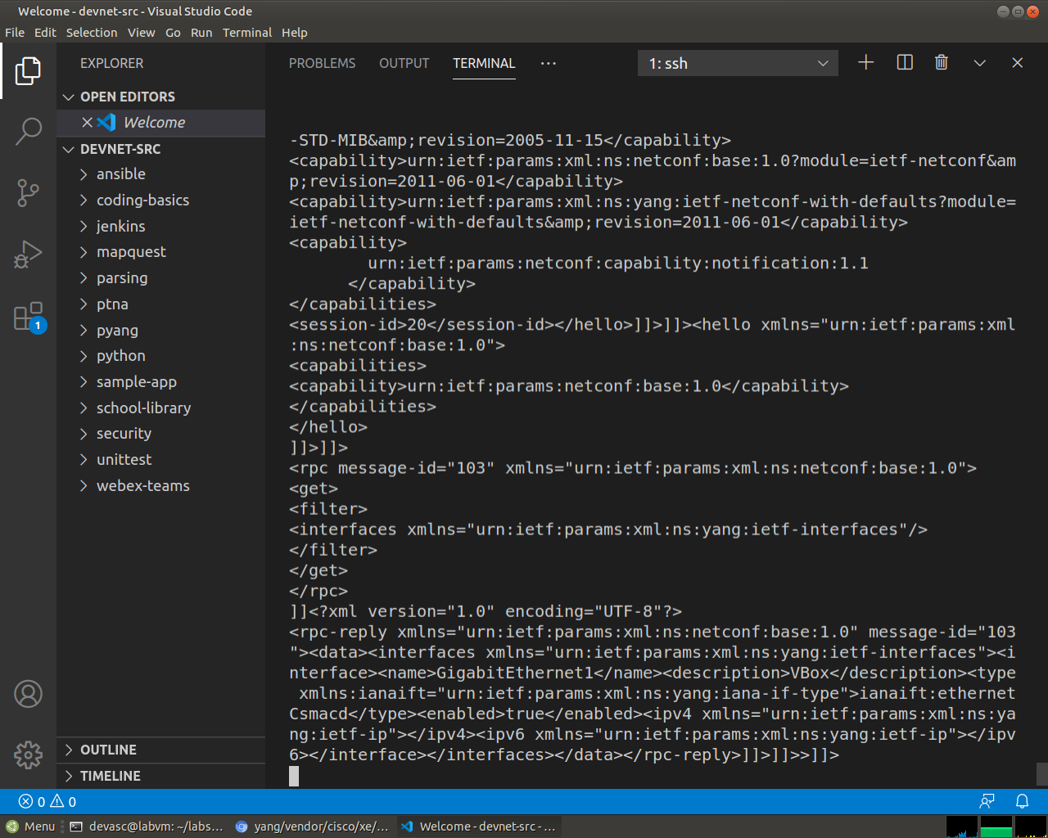
Screenshot 10: The get RPC and the reply, which is one long line of XML for GigabitEthernet1 with the description VBox.
      - Recall that XML does not require indention or white space. Therefore, the CSR1kv will return a long string of XML data.
<?xml version="1.0" encoding="UTF-8"?>
<rpc-reply xmlns="urn:ietf:params:xml:ns:netconf:base:1.0" message-id="103"><data><interfaces xmlns="urn:ietf:params:xml:ns:yang:ietf-interfaces"><interface><name>GigabitEthernet1</name><description>VBox</description><type xmlns:ianaift="urn:ietf:params:xml:ns:yang:iana-if-type">ianaift:ethernetCsmacd</type><enabled>true</enabled><ipv4 xmlns="urn:ietf:params:xml:ns:yang:ietf-ip"></ipv4><ipv6 xmlns="urn:ietf:params:xml:ns:yang:ietf-ip"></ipv6></interface></interfaces></data></rpc-reply>]]>]]>
      - Copy the XML that was returned, but do not include the final “]]>]]>” characters. These characters are not part of the XML that is returned by the router.
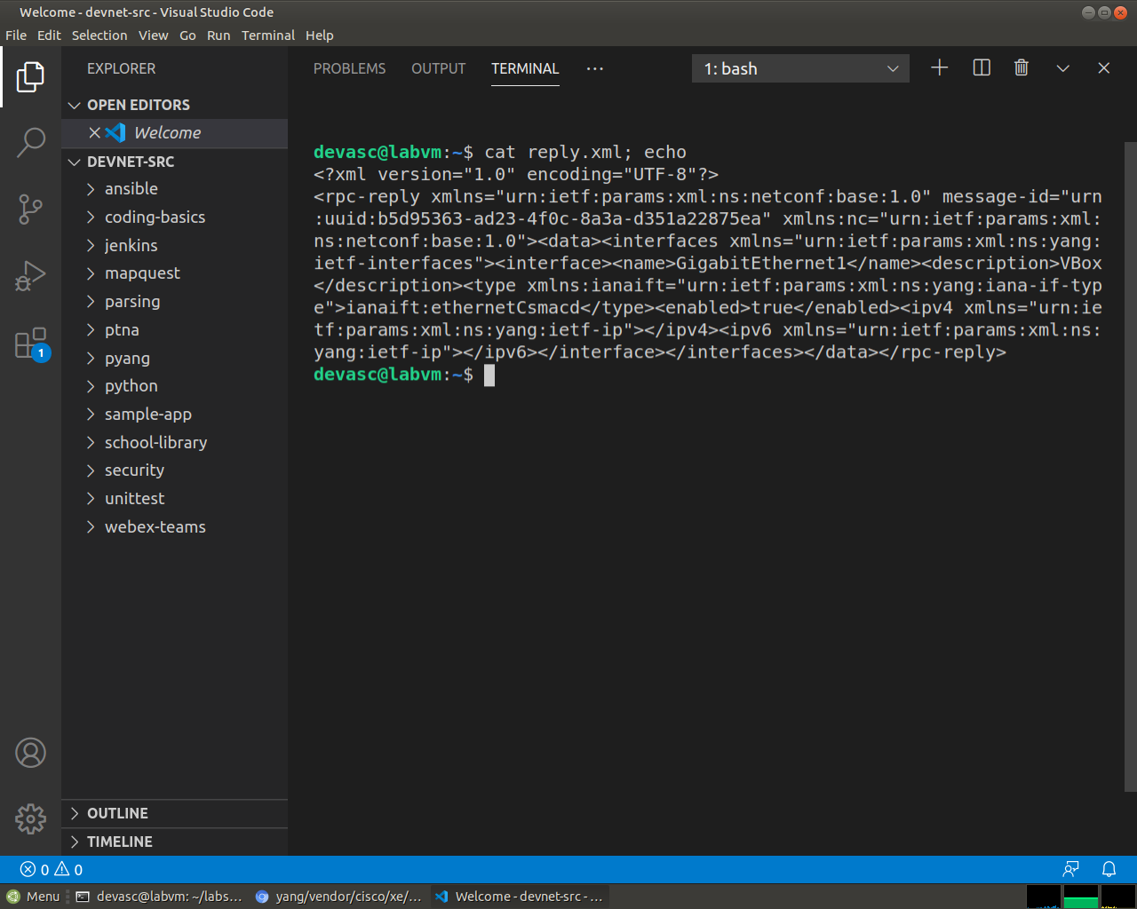
Screenshot 11: The same reply saved to a text file, still one unformatted line.
      - Search the internet for “prettify XML”. Find a suitable site and use its tool to transform your XML into a more readable format, such as the following:
<?xml version="1.0"?>
<rpc-reply xmlns="urn:ietf:params:xml:ns:netconf:base:1.0" message-id="103">
<data>
<interfaces xmlns="urn:ietf:params:xml:ns:yang:ietf-interfaces">
<interface>
<name>GigabitEthernet1</name>
<description>VBox</description>
<type xmlns:ianaift="urn:ietf:params:xml:ns:yang:iana-if-type">ianaift:ethernetCsmacd</type>
<enabled>true</enabled>
<ipv4 xmlns="urn:ietf:params:xml:ns:yang:ietf-ip"/>
<ipv6 xmlns="urn:ietf:params:xml:ns:yang:ietf-ip"/>
</interface>
</interfaces>
</data>
</rpc-reply>
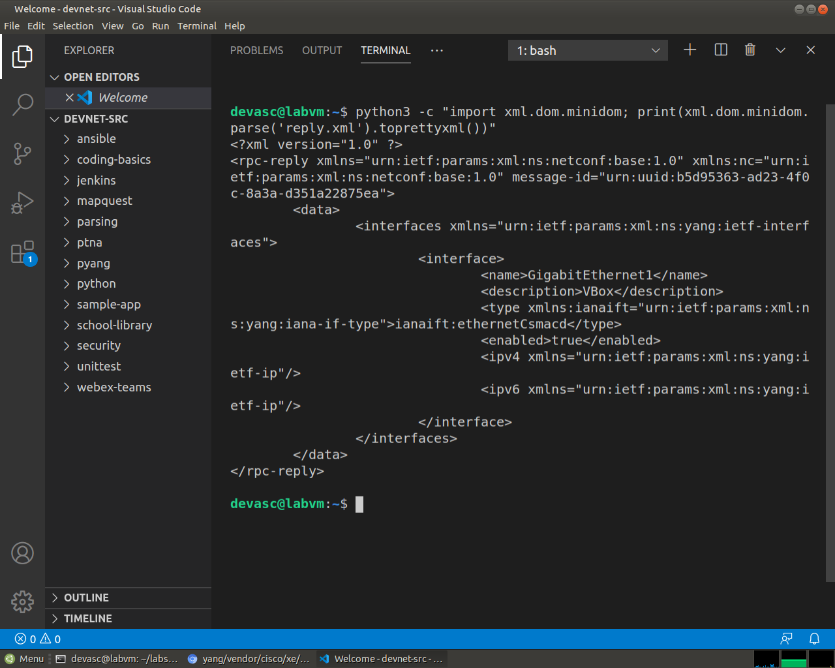
Screenshot 12: The reply prettified with the xml.dom.minidom module in the VM instead of a website, which makes the name, description, type and enabled state easy to read.

Close the NETCONF session.
      - To close the NETCONF session, the client needs to send the following RPC message:
<rpc message-id="9999999" xmlns="urn:ietf:params:xml:ns:netconf:base:1.0">
<close-session />
</rpc>
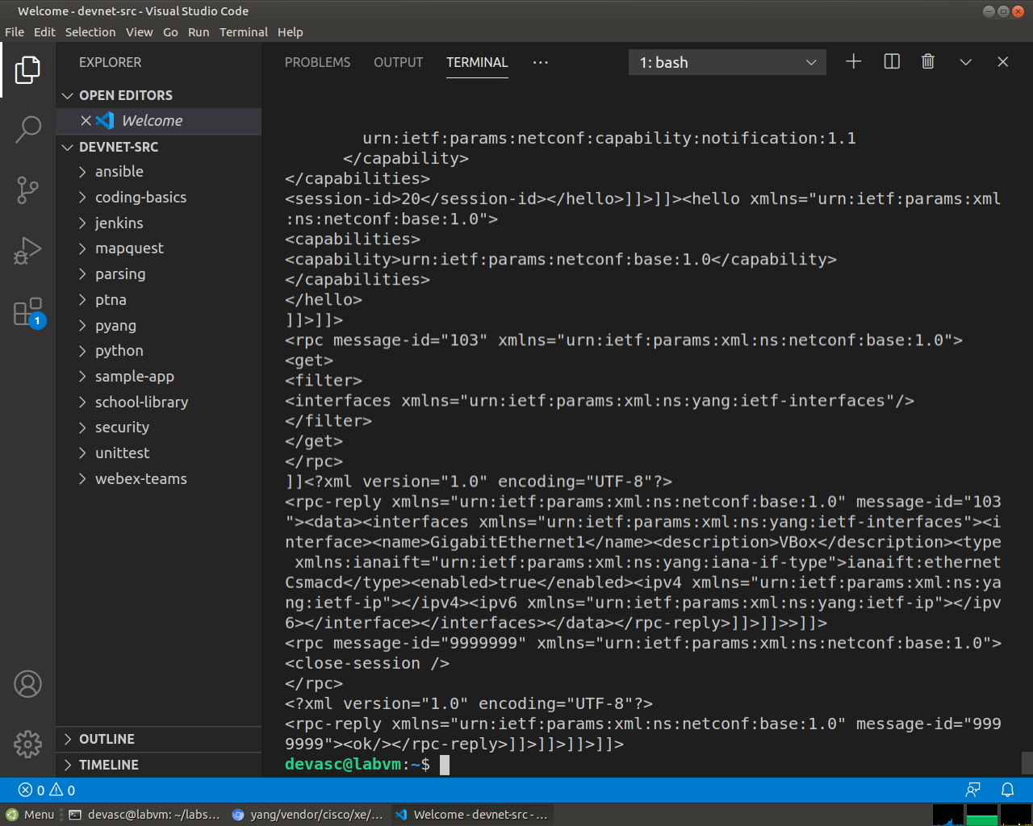
Screenshot 13: The close-session RPC, which the router answered with <ok/>.
      - After a few seconds, you will be returned to the terminal prompt. Return to the CSR1kv prompt and show the open netconf sessions. You will see that the session has been closed.
CSR1kv# show netconf-yang sessions
There are no active sessions

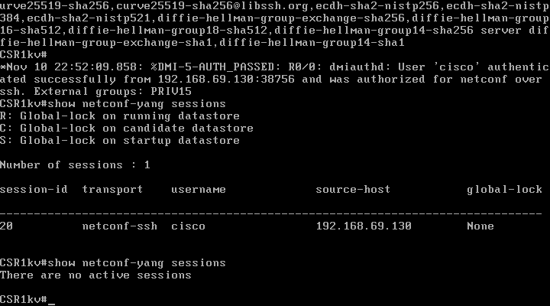
Screenshot 14: Back on the CSR1kv console, show netconf-yang sessions now says There are no active sessions.
CSR1kv#

Use ncclient to Connect to NETCONF
Working with NETCONF does not require working with raw NETCONF RPC messages and XML. In this Part, you will learn how to use the ncclient Python module to easily interact with network devices using NETCONF. In addition, you will learn how to identify which YANG models are supported by the device. This information is helpful when building a production network automation system that requires specific YANG models to be supported by the given network device.

Verify that ncclient is installed and ready for use.
In a DEVASC-VM terminal, enter the command pip3 list --format=columns to see all Python modules currently installed. Pipe the output to more. Your output may differ from the following. But you should see ncclient listed, as shown. If not, use the pip3 install ncclient command to install it.
devasc@labvm:~$ pip3 list --format=columns | more
Package Version
---------------------- -----------
ansible 2.9.6
apache-libcloud 2.8.0
appdirs 1.4.3
argcomplete 1.8.1
astroid 2.3.3
(output omitted)
ncclient 0.6.7
netaddr 0.7.19
netifaces 0.10.4
netmiko 3.1.0
ntlm-auth 1.1.0
oauthlib 3.1.0
(output omitted)
xmltodict 0.12.0
zipp 1.0.0
devasc@labvm:~$
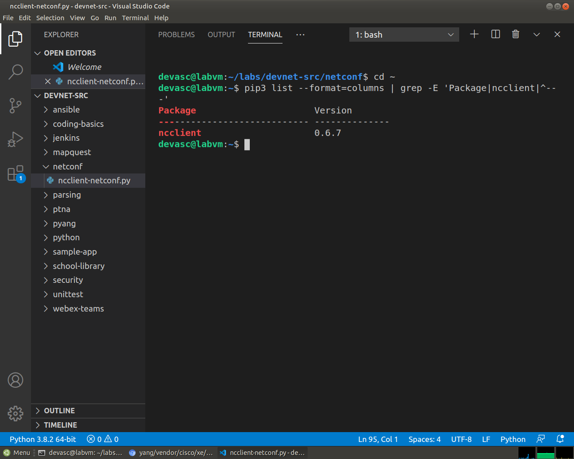
Screenshot 15: pip3 list shows ncclient 0.6.7 is already installed in the DEVASC VM.

Create a script to use ncclient to connect to the NETCONF service.
The ncclient module provides a manager class with a connect() method to setup the remote NETCONF connections. After a successful connection, the returned object represents the NETCONF connection to the remote device.
      - In VS code, click File > Open Folder... and navigate to the devnet-src directory. Click OK.
      - Open a terminal window in VS Code: Terminal > New Terminal.
      - Create a subdirectory called netconf in the /devnet-src directory.
devasc@labvm:~/labs/devnet-src$ mkdir netconf
devasc@labvm:~/labs/devnet-src$
      - In the EXPLORER pane under DEVNET-SRC, right-click the netconf directory and choose New File.
      - Name the file ncclient-netconf.py.
      - In your script file, import the manager class from the ncclient module. Then create a variable m to represent the connect() method. The connect() method includes all the information that is required to connect to the NETCONF service running on the CSR1kv. Note that the port is 830 for NETCONF.
from ncclient import manager

m = manager.connect(
host="192.168.56.101",
port=830,
username="cisco",
password="cisco123!",
hostkey_verify=False
)
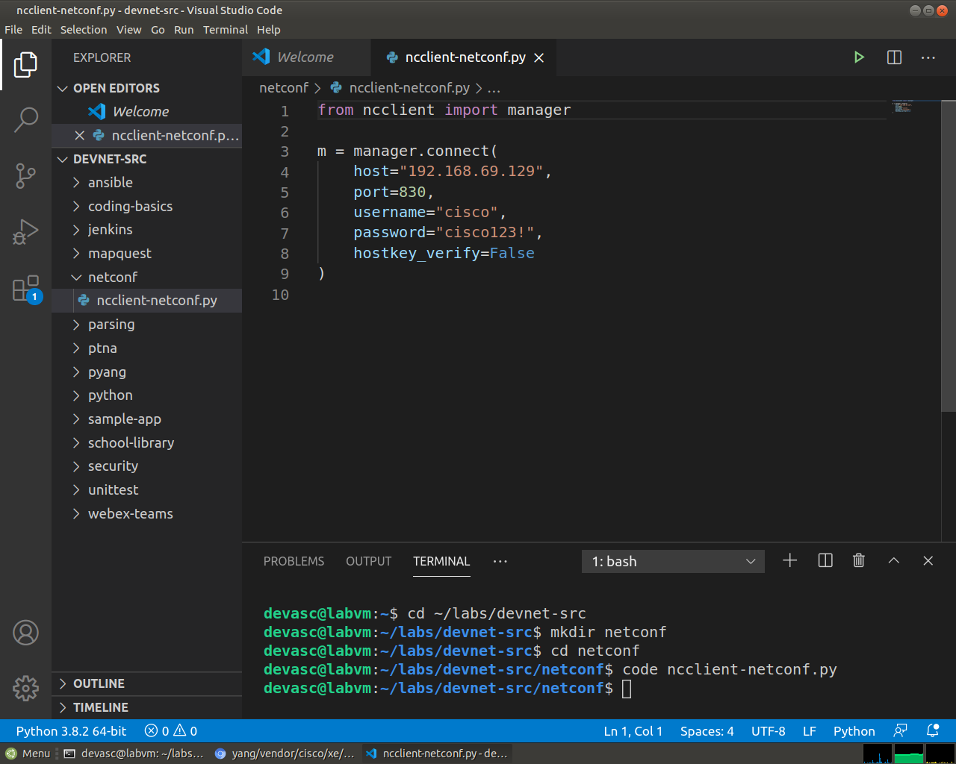
Screenshot 16: VS Code with the new netconf folder and ncclient-netconf.py, which imports manager and connects on port 830 with hostkey_verify set to False.
If the hostkey_verify is set to True, the CSR1kv will ask you to verify the SSH fingerprint. In a lab environment, it is safe to set this value to False, as we have done here.
      - Save and run the program to verify that there are no errors. You will not see any output yet.
devasc@labvm:~/labs/devnet-src$ cd netconf/
devasc@labvm:~/labs/devnet-src/netconf$ python3 ncclient-netconf.py
devasc@labvm:~/labs/devnet-src/netconf$
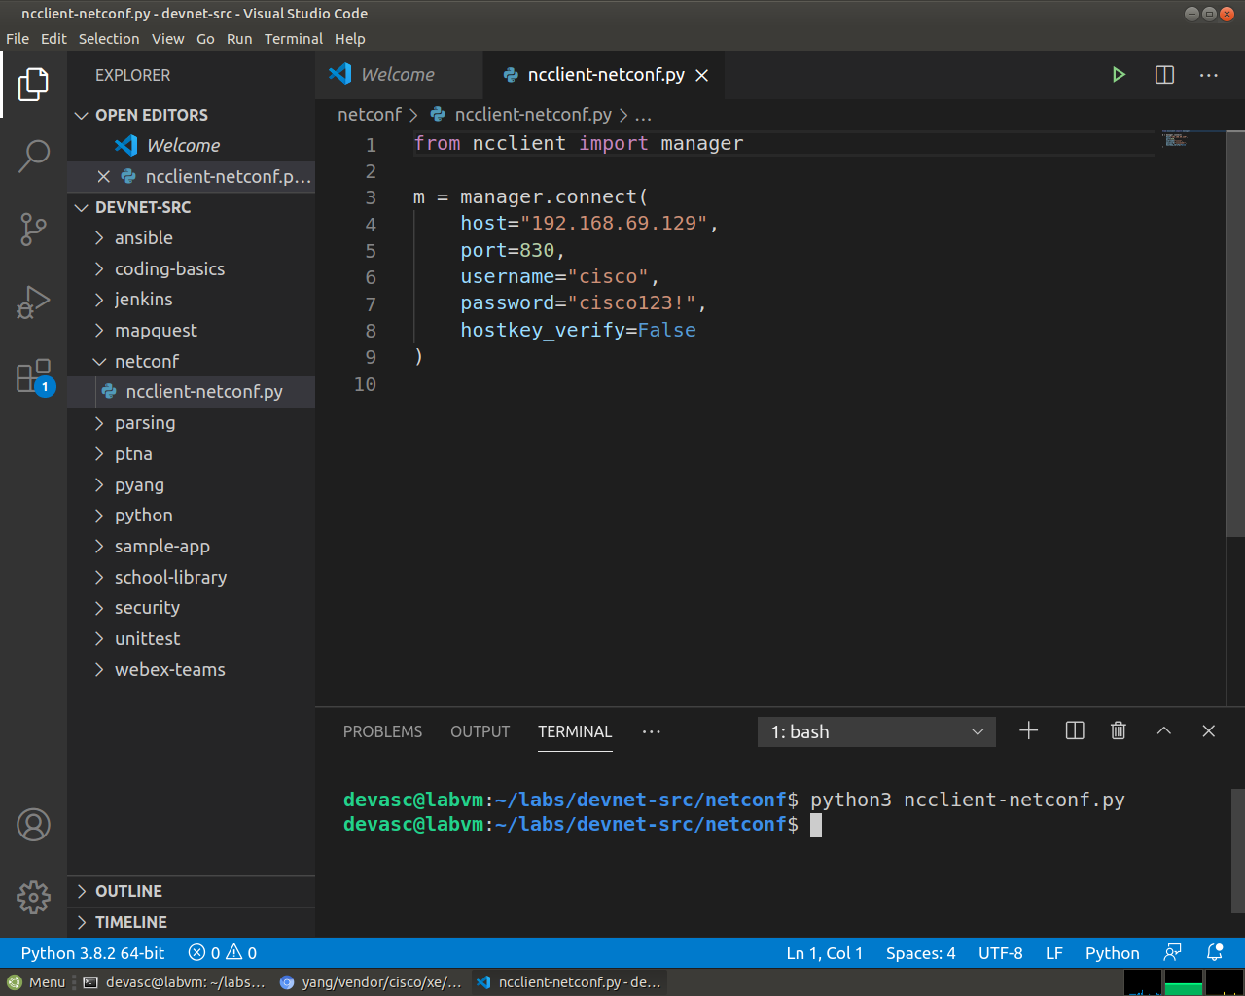
Screenshot 17: Running the script prints nothing, so the connection worked.
      - You can verify that the CSR1kv accepted the request for a NETCONF session. There should be an %DMI-5-AUTH_PASSED syslog message in the CSR1kv VM. If the screen is black, press Enter to wake the router. The syslog message can be seen above the banner.
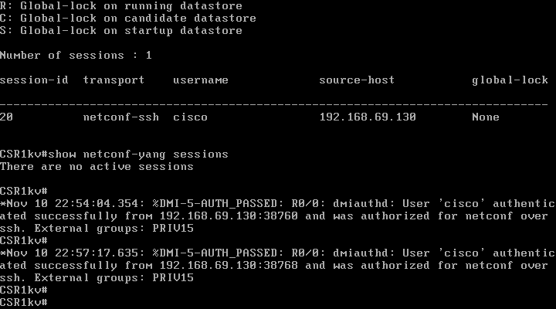
Screenshot 18: The CSR1kv console printed %DMI-5-AUTH_PASSED for every login from 192.168.69.130, which means the router accepted the NETCONF requests.

Add a print function to the script so that the NETCONF capabilities for the CSR1kv are listed.
The m object returned by the manager.connect() function represents the NETCONF remote session. As you saw previously, in every NETCONF session, the server first sends its capabilities, which is a list, in XML format, of supported YANG models. With the ncclient module, the received list of capabilities is stored in the m.server_capabilities list.
      - Use a for loop and a print function to display the device capabilities:
print("#Supported Capabilities (YANG models):")
for capability in m.server_capabilities:
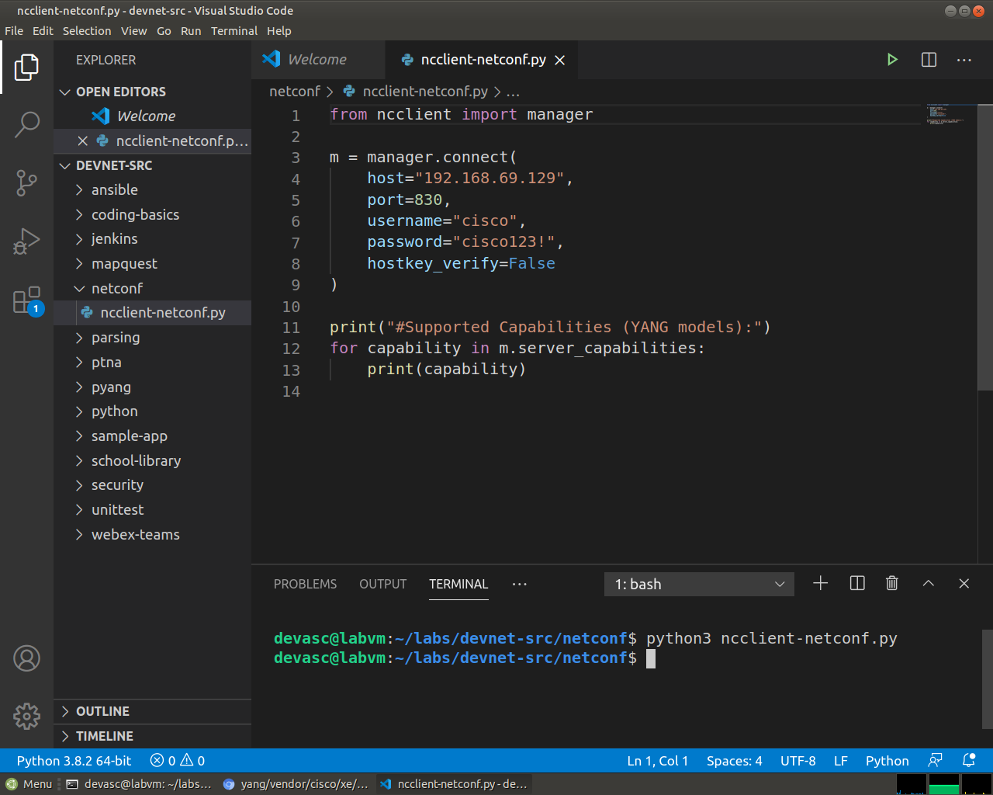
Screenshot 19: The for loop that prints every item in m.server_capabilities.
print(capability)
      - Save and run the program. The output is the same output you got from sending the complex hello message in previously, but without the opening and closing <capability> XML tag on each line.
devasc@labvm:~/labs/devnet-src/netconf$ python3 ncclient-netconf.py
#Supported Capabilities (YANG models):
urn:ietf:params:netconf:base:1.0
urn:ietf:params:netconf:base:1.1
urn:ietf:params:netconf:capability:writable-running:1.0
urn:ietf:params:netconf:capability:xpath:1.0
<output omitted>
urn:ietf:params:xml:ns:netconf:base:1.0?module=ietf-netconf&revision=2011-06-01
urn:ietf:params:xml:ns:yang:ietf-netconf-with-defaults?module=ietf-netconf-with-defaults&revision=2011-06-01

urn:ietf:params:netconf:capability:notification:1.1

devasc@labvm:~/labs/devnet-src/netconf$
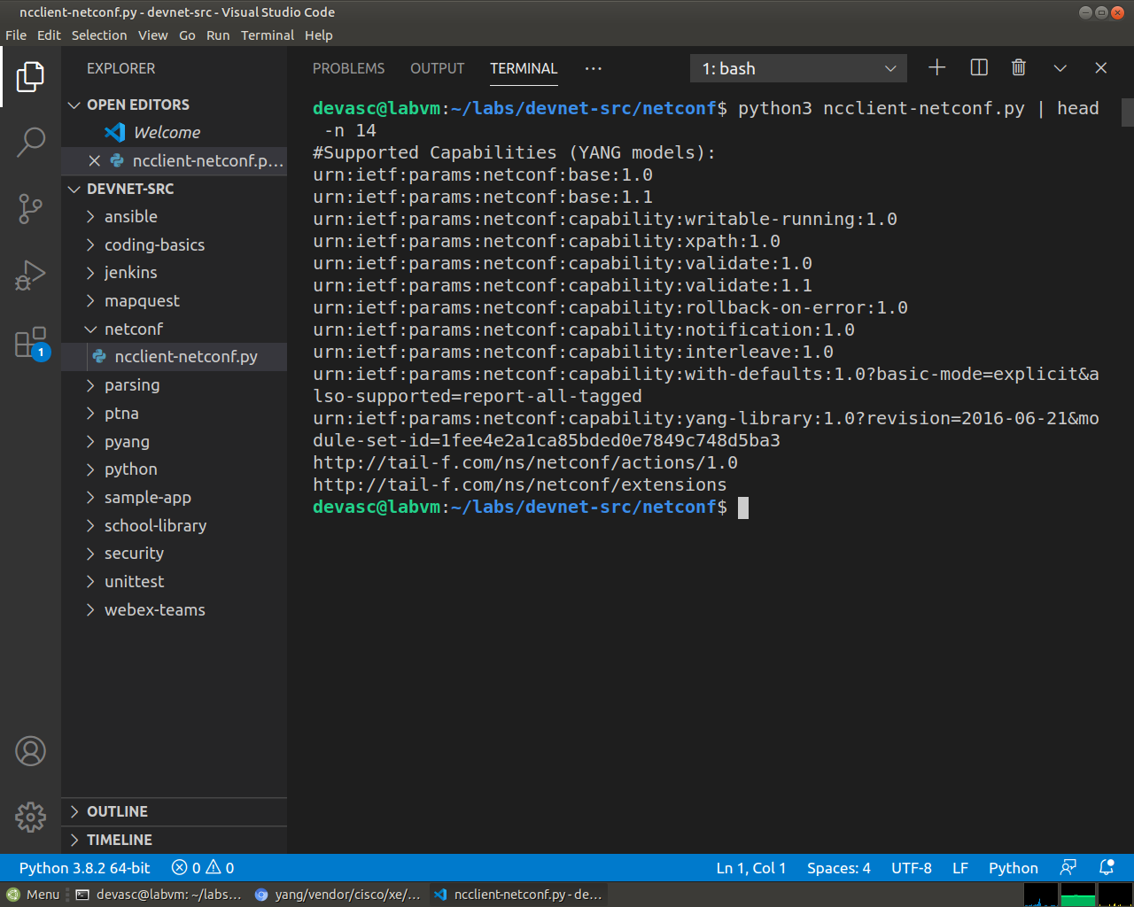
Screenshot 20: The first lines of the output, starting with the base capabilities.
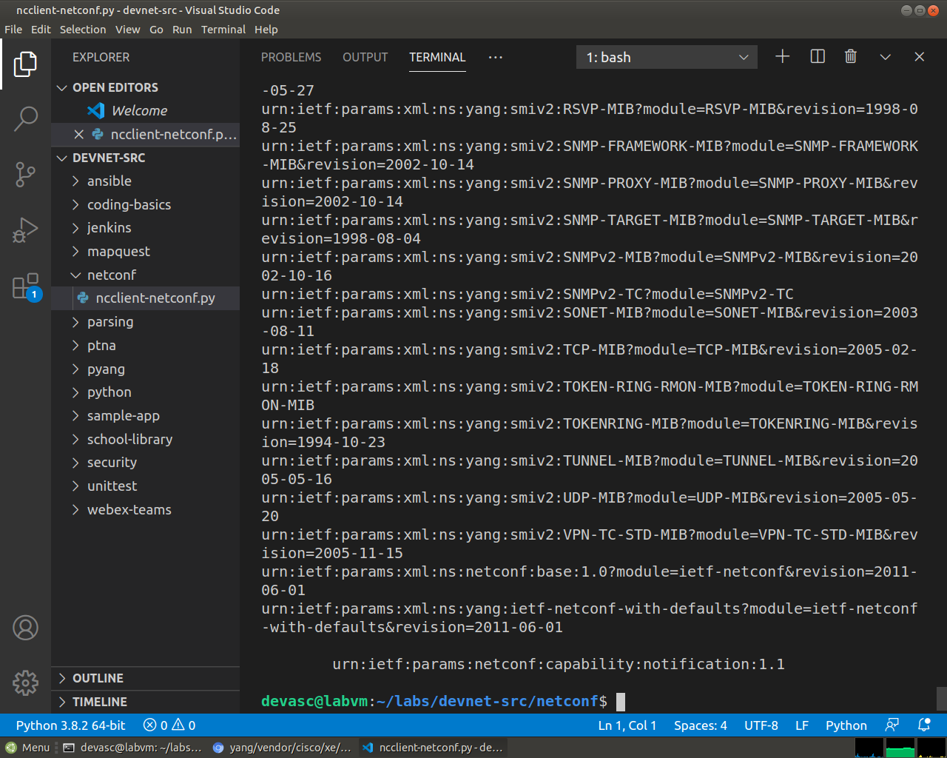
Screenshot 21: The end of the capabilities list, which is the same list as the hello message but without the XML tags.

Use ncclient to Retrieve the Configuration
In this Part, you will use the NETCONF ncclient to retrieve the configuration for the CSR1kv, use the xml.dom.minidom module to format the configuration, and use a filter with get_config() to retrieve a portion of the running configuration.

Use the get_config() function to retrieve the running configuration for R1.
      - If you want to skip displaying capabilities output (400+ lines), comment out the block of statements that print the capabilities, as shown in the following:
'''
print("#Supported Capabilities (YANG models):")
for capability in m.server_capabilities:
print(capability)
'''
      - You can use the get_config() method of the m NETCONF session object to retrieve the configuration for the CSR1kv. The get_config() method expects a source string parameter that specifies the source NETCONF datastore. Use a print function to display the results. The only NETCONF datastore currently on the CSR1kv is the running datastore. You can verify this with the show netconf-yang datastores command.
netconf_reply = m.get_config(source="running")
print(netconf_reply)
      - Save and run your program. The output will be well over 100 lines, so IDLE may compress them. Double-click the Squeezed text message in the IDLE shell window to expand the output.
devasc@labvm:~/labs/devnet-src/netconf$ python3 ncclient-netconf.py
<?xml version="1.0" encoding="UTF-8"?>
<rpc-reply xmlns="urn:ietf:params:xml:ns:netconf:base:1.0" message-id="urn:uuid:3f31bedc-5671-47ca-9781-4d3d7aadae24" xmlns:nc="urn:ietf:params:xml:ns:netconf:base:1.0"><data><native xmlns="http://cisco.com/ns/yang/Cisco-IOS-XE-native"><version>16.9</version><boot-start-marker/><boot-end-marker/><banner><motd><banner>
(output omitted)
devasc@labvm:~/labs/devnet-src/netconf$
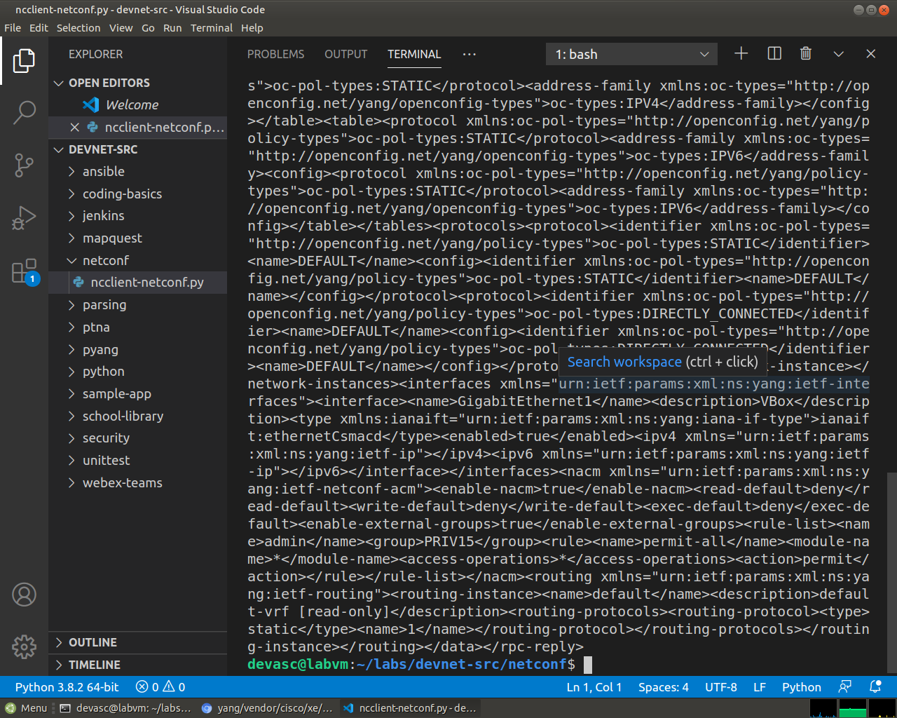
Screenshot 22: get_config on the running datastore, which prints the whole configuration as raw, unformatted XML.
      - Notice that the returned XML is not formatted. You can copy it out to the same site you found earlier to prettify the XML.
<?xml version="1.0" encoding="UTF-8"?>
<rpc-reply xmlns="urn:ietf:params:xml:ns:netconf:base:1.0" xmlns:nc="urn:ietf:params:xml:ns:netconf:base:1.0" message-id="urn:uuid:3f31bedc-5671-47ca-9781-4d3d7aadae24">
<data>
<native xmlns="http://cisco.com/ns/yang/Cisco-IOS-XE-native">
<version>16.9</version>
<boot-start-marker/>
<boot-end-marker/>
<banner>
<motd>
<banner>^C</banner>
</motd>
</banner>
<service>
<timestamps>
<debug>
<datetime>
<msec/>
</datetime>
</debug>
<log>
<datetime>
<msec/>
</datetime>
</log>
</timestamps>
</service>
<platform>
<console xmlns="http://cisco.com/ns/yang/Cisco-IOS-XE-platform">
<output>virtual</output>
</console>
</platform>
<hostname>CSR1kv</hostname>
(output omitted)

Use Python to prettify the XML.
Python has built in support for working with XML files. The xml.dom.minidom module can be used to prettify the output with the toprettyxml() function.
      - At the beginning of your script, add a statement to import the xml.dom.minidom module.
import xml.dom.minidom
      - Replace the simple print function print(netconf_reply) with a version that prints prettified XML output.
print(xml.dom.minidom.parseString(netconf_reply.xml).toprettyxml())
      - Save and run your program. XML is displayed in a more readable format.
devasc@labvm:~/labs/devnet-src/netconf$ python3 ncclient-netconf.py
<?xml version="1.0" ?>
<rpc-reply xmlns="urn:ietf:params:xml:ns:netconf:base:1.0" xmlns:nc="urn:ietf:params:xml:ns:netconf:base:1.0" message-id="urn:uuid:3a5f6abc-76b4-436d-9e9a-7758091c28b7">
<data>
<native xmlns="http://cisco.com/ns/yang/Cisco-IOS-XE-native">
<version>16.9</version>
<boot-start-marker/>
<boot-end-marker/>
<banner>
<motd>
<banner>^C</banner>
</motd>
</banner>
(output omitted)
</data>
</rpc-reply>

devasc@labvm:~/labs/devnet-src/netconf$
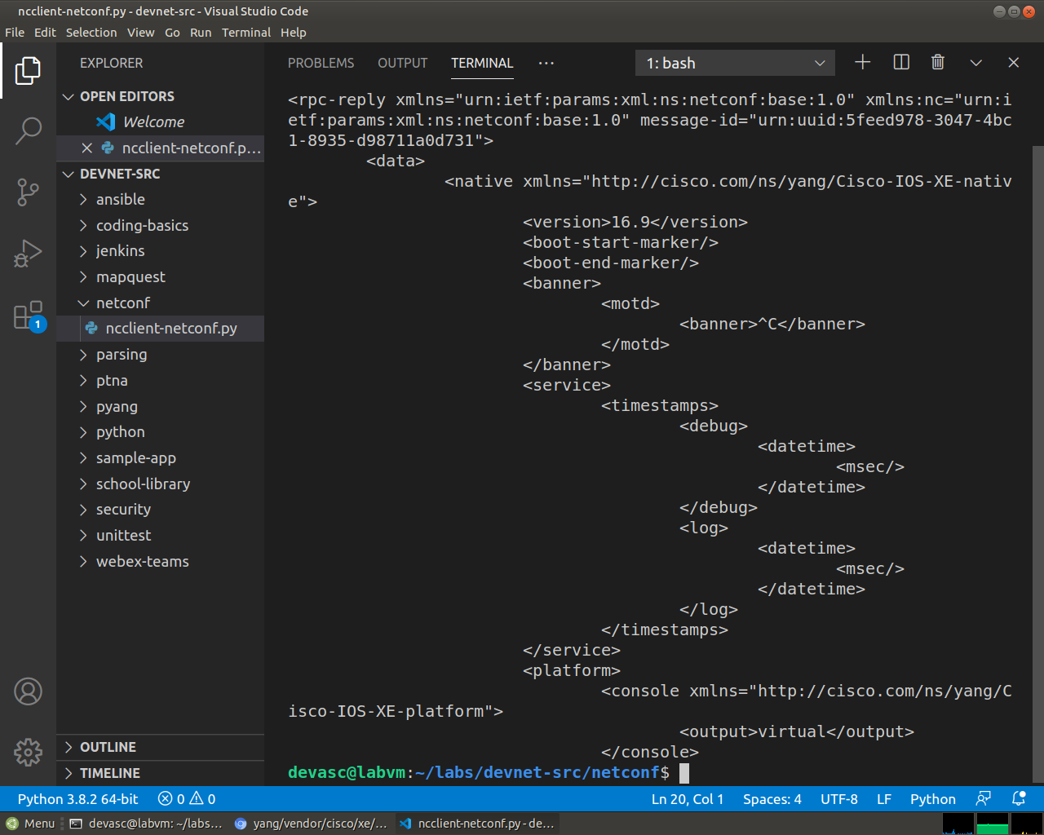
Screenshot 23: The same configuration after toprettyxml(), starting with the version 16.9, the banner, the service timestamps and the platform console.

Use a filter with get_config() to only retrieve a specific YANG model.
A network administrator may only want to retrieve a portion of the running configuration on a device. NETCONF supports returning only data that is defined in a filter parameter of the get_conf() function.
      - Create a variable called netconf_filter that only retrieves data defined by the Cisco IOS XE Native YANG model.
netconf_filter = """
<filter>
<native xmlns="http://cisco.com/ns/yang/Cisco-IOS-XE-native" />
</filter>
"""
netconf_reply = m.get_config(source="running", filter=netconf_filter)
print(xml.dom.minidom.parseString(netconf_reply.xml).toprettyxml())
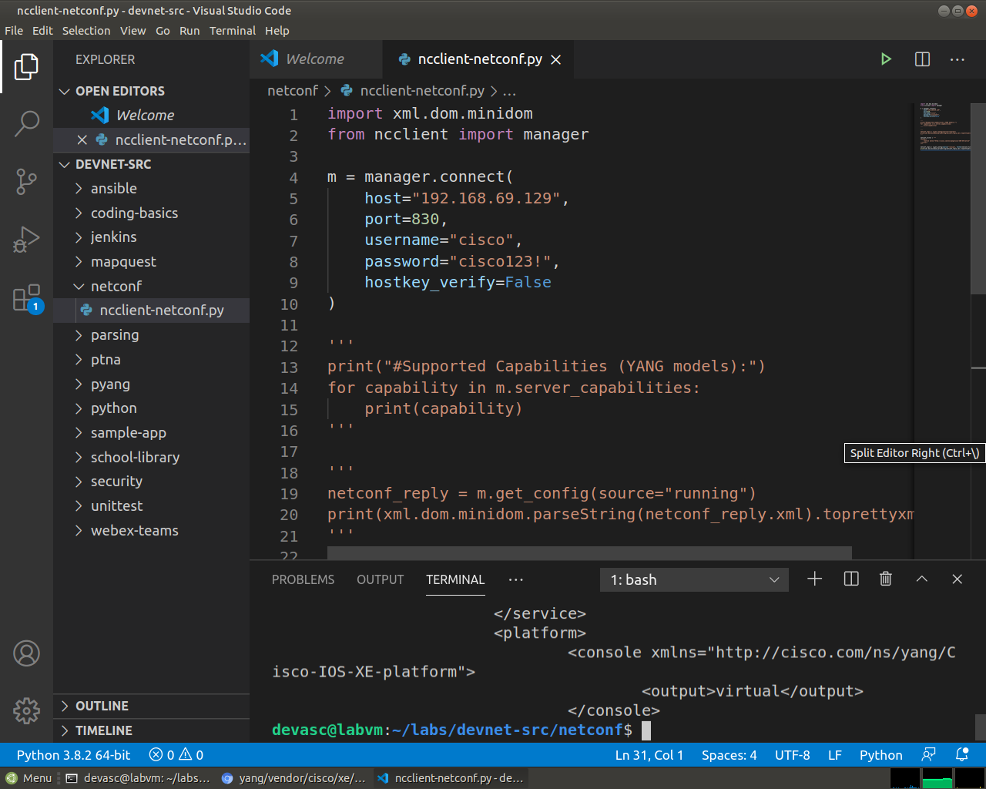
Screenshot 24: The netconf_filter variable and the get_config call that uses it.
      - Save and run your program. The start of the output is the same, as shown below. However, only the <native> XML element is displayed this time. Previously, all the YANG models available on the CSR1kv were displayed. Filtering the retrieved data to only display the native YANG module significantly reduces your output. This is because the native YANG module only includes a subset of all the Cisco IOX XE YANG models.
devasc@labvm:~/labs/devnet-src/netconf$ python3 ncclient-netconf.py
<?xml version="1.0" ?>
<rpc-reply xmlns="urn:ietf:params:xml:ns:netconf:base:1.0" xmlns:nc="urn:ietf:params:xml:ns:netconf:base:1.0" message-id="urn:uuid:4da5b736-1d33-47c3-8e3c-349414be0958">
<data>
<native xmlns="http://cisco.com/ns/yang/Cisco-IOS-XE-native">
<version>16.9</version>
<boot-start-marker/>
<boot-end-marker/>
<banner>
<motd>
<banner>^C</banner>
</motd>
</banner>
<service>
<timestamps>
<debug>
<datetime>
<msec/>
</datetime>
</debug>
<log>
<datetime>
<msec/>
</datetime>
</log>
</timestamps>
</service>
<platform>
<console xmlns="http://cisco.com/ns/yang/Cisco-IOS-XE-platform">
<output>virtual</output>
</console>
</platform>
<hostname>CSR1kv</hostname>
(output omitted)
</native>
</data>
</rpc-reply>

devasc@labvm:~/labs/devnet-src/netconf$
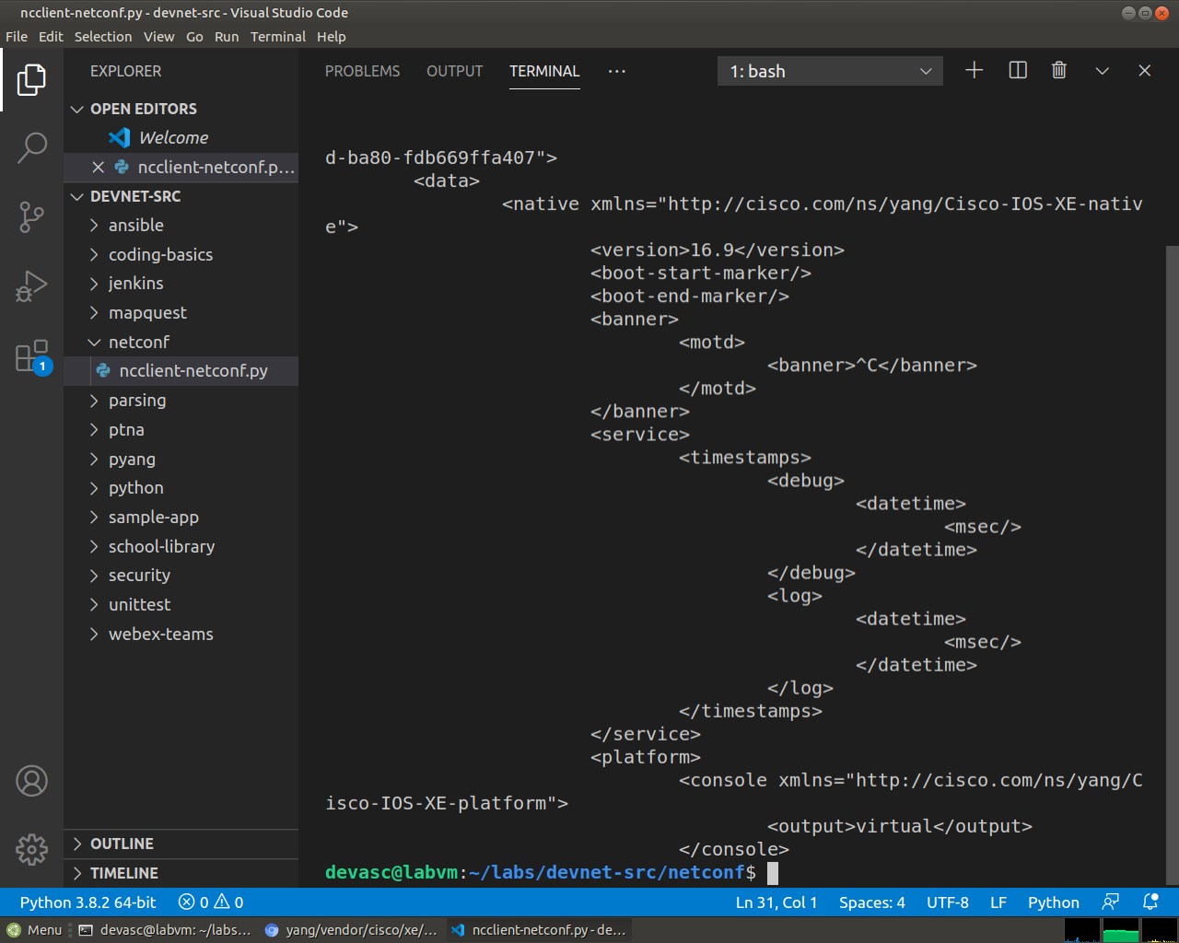
Screenshot 25: Only the Cisco-IOS-XE-native model comes back now, which keeps the output much shorter.

Use ncclient to Configure a Device
In this Part, you will use ncclient to configure the CSR1kv using the edit_config() method of the manager module.

Use ncclient to edit the hostname for the CSR1kv.
To update an existing setting in the configuration for the CSR1kv, you can extract the setting location from the configuration retrieved previously. For this step, you will set a variable to change the <hostname> value.
devasc@labvm:~/labs/devnet-src/netconf$ python3 ncclient-netconf.py
<?xml version="1.0" ?>
<rpc-reply xmlns="urn:ietf:params:xml:ns:netconf:base:1.0" xmlns:nc="urn:ietf:params:xml:ns:netconf:base:1.0" message-id="urn:uuid:4da5b736-1d33-47c3-8e3c-349414be0958">
<data>
<native xmlns="http://cisco.com/ns/yang/Cisco-IOS-XE-native">
(output omitted)
<hostname>CSR1kv</hostname>
(output omitted)
      - Previously, you defined a <filter> variable. To modify a device configuration, you will define a <config> variable. Add the following variable to your ncclient_netconf.py script. You can use NEWHOSTNAME or whatever hostname you wish.
netconf_hostname = """
<config>
<native xmlns="http://cisco.com/ns/yang/Cisco-IOS-XE-native">
<hostname>NEWHOSTNAME</hostname>
</native>
</config>
"""
      - Use the edit_config() function of the m NETCONF session object to send the configuration and store the results in the netconf_reply variable so that they can be printed. The parameters for the edit_config() function are as follows:
- target - the targeted NETCONF datastore to be updated
- config - the configuration modification that is to be sent
netconf_reply = m.edit_config(target="running", config=netconf_hostname)
      - The edit_config() function returns an XML RPC reply message with <ok/> indicating that the change was successfully applied. Repeat the previous print statement to display the results.
print(xml.dom.minidom.parseString(netconf_reply.xml).toprettyxml())
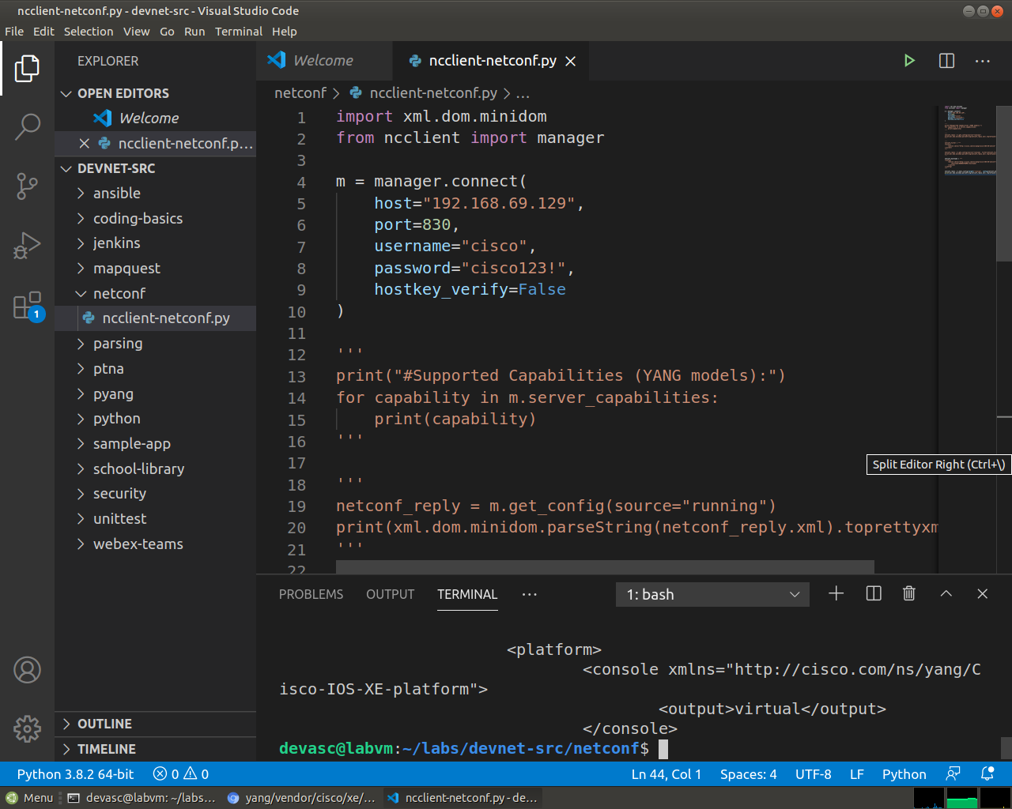
Screenshot 26: netconf_hostname with NEWHOSTNAME, sent with edit_config.
      - Save and run your program. You should get output similar to the output displayed below. You can also verify that the hostname has changed by switching to the CSR1kv VM.
devasc@labvm:~/labs/devnet-src/netconf$ python3 ncclient-netconf.py
(output omitted)
<?xml version="1.0" ?>
<rpc-reply xmlns="urn:ietf:params:xml:ns:netconf:base:1.0" xmlns:nc="urn:ietf:params:xml:ns:netconf:base:1.0" message-id="urn:uuid:e304b225-7951-4029-afd5-59e8e7edbaa0">
<ok/>
</rpc-reply>

devasc@labvm:~/labs/devnet-src/netconf$
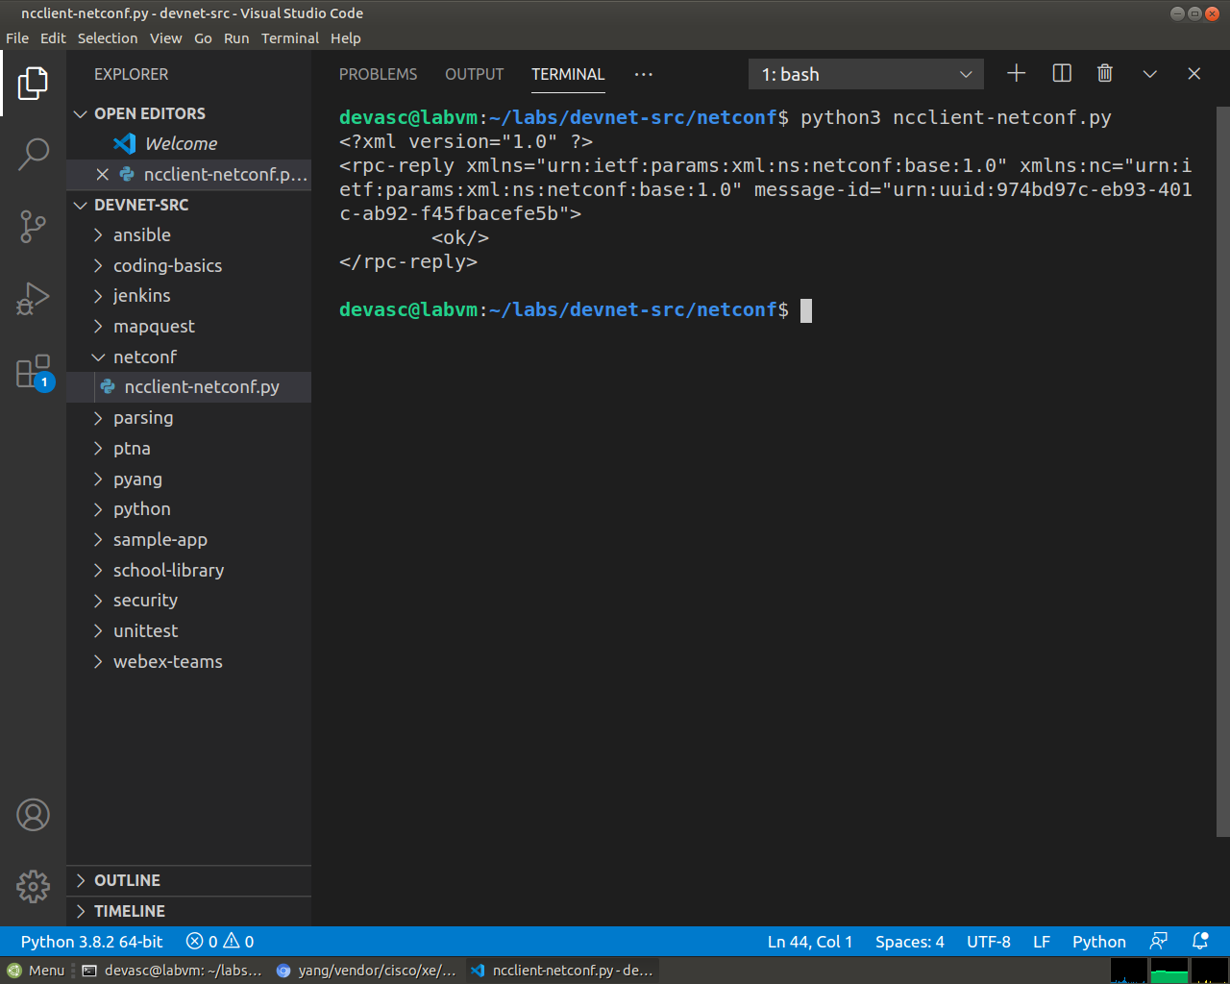
Screenshot 27: The reply is <ok/>, so the hostname change was applied.
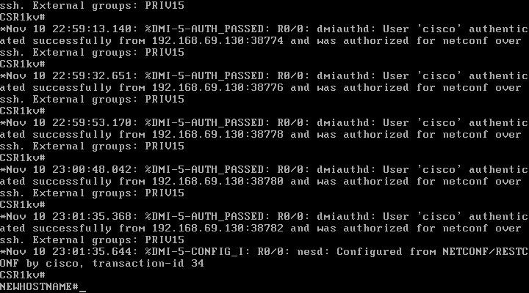
Screenshot 28: The CSR1kv prompt became NEWHOSTNAME#, with a %DMI-5-CONFIG_I message saying it was configured from NETCONF.
      - Edit your script to change hostname back to CSR1kv. Save and run your program. You can also just comment out the code from the previous step if you want to avoid changing the hostname again.
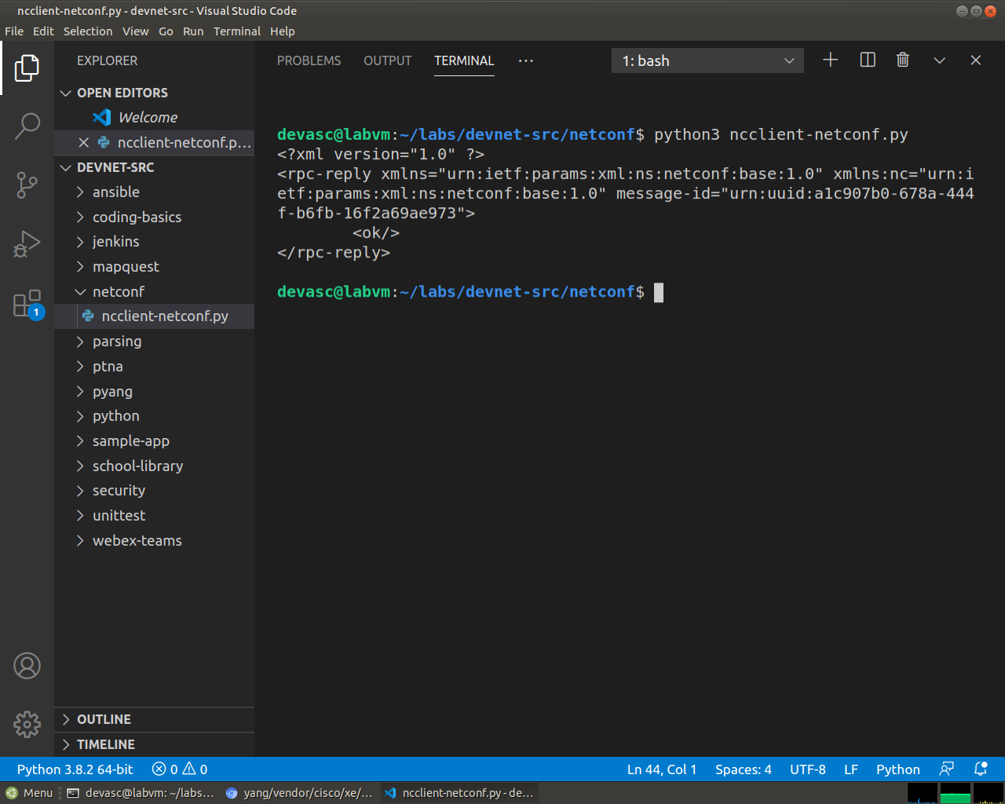
Screenshot 29: The hostname was changed back to CSR1kv with the same script, and the reply is <ok/> again.
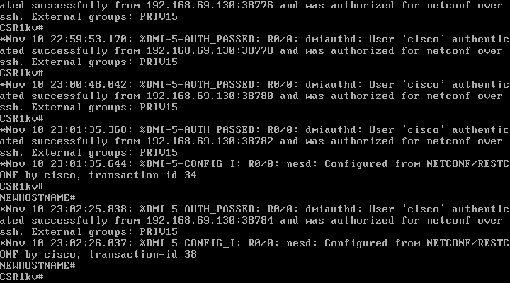
Screenshot 30: The console prompt is CSR1kv# again.

Use ncclient to create a new loopback interface on R1.
      - Create a new <config> variable to hold the configuration for a new loopback interface. Add the following to your ncclient_netconf.py script.
Note: You can use whatever description you want. However, only use alphanumeric characters or you will need to escape them with the backslash ( \ ).
netconf_loopback = """
<config>
<native xmlns="http://cisco.com/ns/yang/Cisco-IOS-XE-native">
<interface>
<Loopback>
<name>1</name>
<description>My first NETCONF loopback</description>
<ip>
<address>
<primary>
<address>10.1.1.1</address>
<mask>255.255.255.0</mask>
</primary>
</address>
</ip>
</Loopback>
</interface>
</native>
</config>
"""
      - Add the following edit_config() function to your ncclient_netconf.py to send the new loopback configuration to R1 and then print out the results.
netconf_reply = m.edit_config(target="running", config=netconf_loopback)
print(xml.dom.minidom.parseString(netconf_reply.xml).toprettyxml())
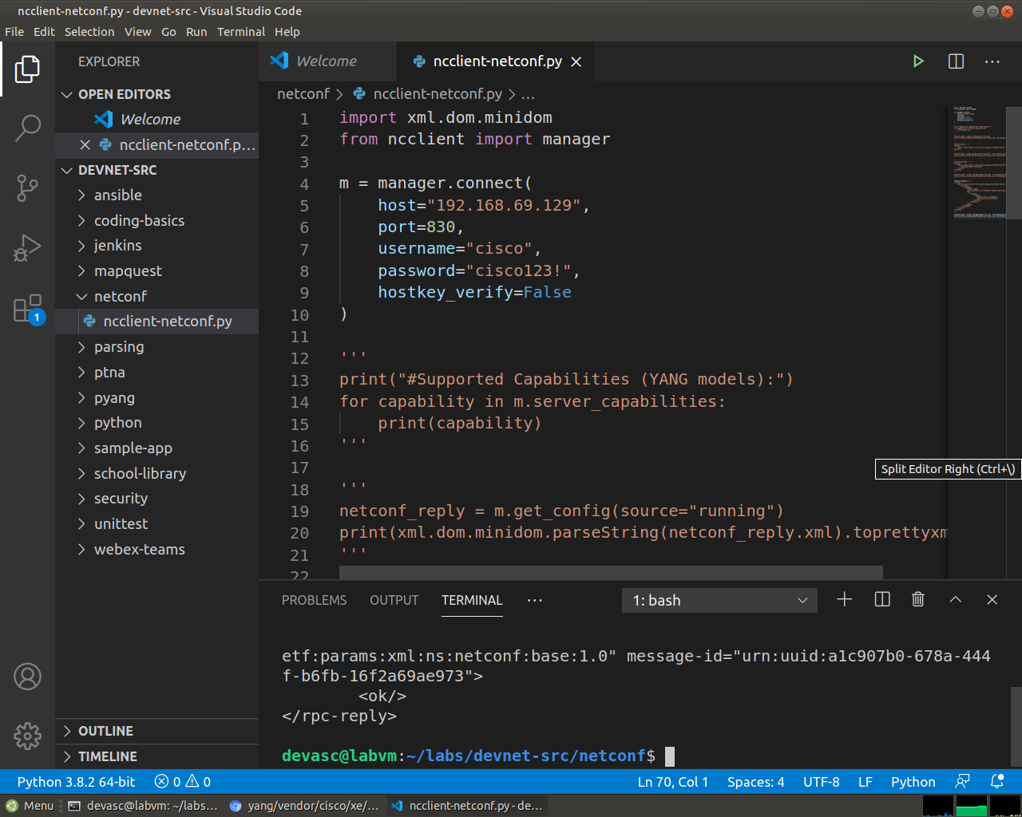
Screenshot 31: netconf_loopback, which creates Loopback1 with 10.1.1.1 255.255.255.0, and its edit_config call.
      - Save and run your program. You should get output similar to the following:

devasc@labvm:~/labs/devnet-src/netconf$ python3 ncclient-netconf.py
(output omitted)
<?xml version="1.0" ?>
<rpc-reply xmlns="urn:ietf:params:xml:ns:netconf:base:1.0" xmlns:nc="urn:ietf:params:xml:ns:netconf:base:1.0" message-id="urn:uuid:98437f47-7a93-4cac-9b9e-9bc8afc9dfa1">
<ok/>
</rpc-reply>

devasc@labvm:~/labs/devnet-src/netconf$
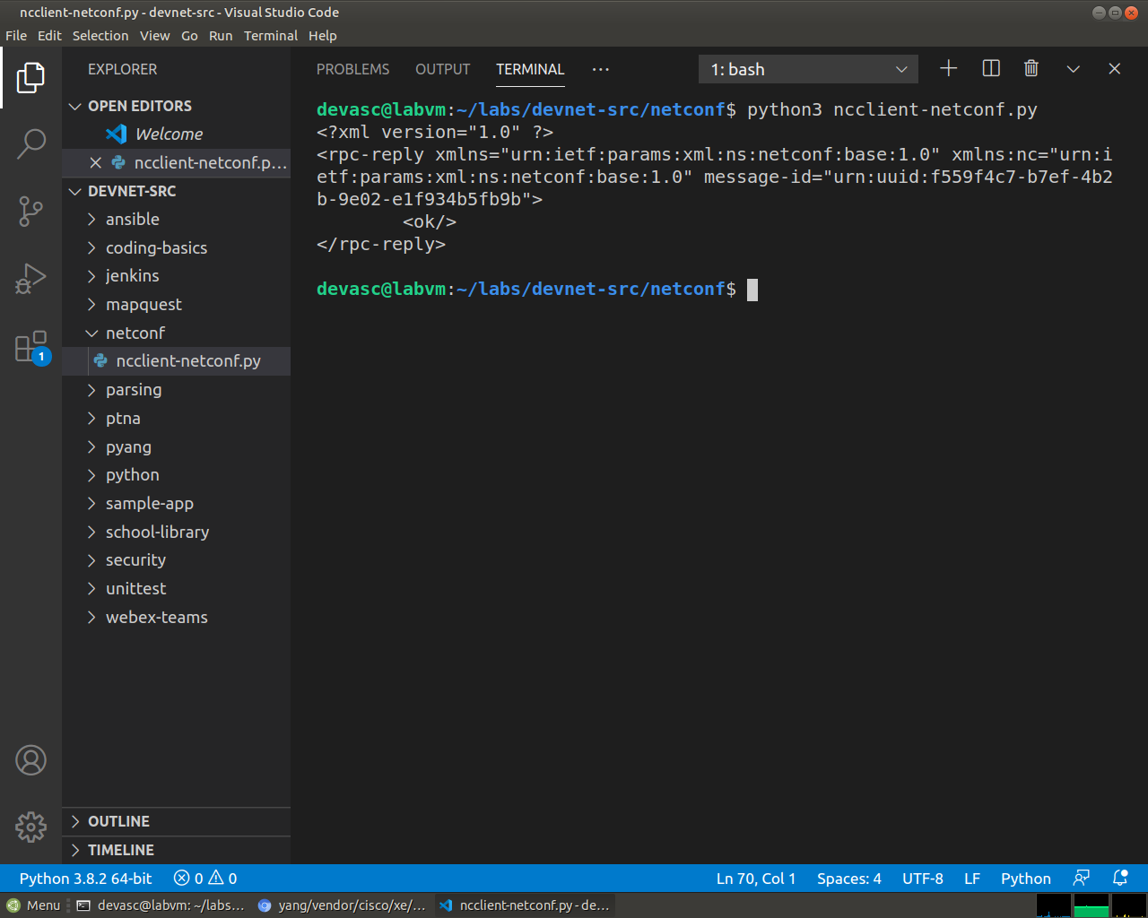
Screenshot 32: The reply is <ok/>, so Loopback1 should exist on the router.
      - On the CSR1kv, verify that the new loopback interface was created.
Open configuration window
CSR1kv>en
CSR1kv# show ip interface brief
Interface IP-Address OK? Method Status Protocol
GigabitEthernet1 192.168.56.101 YES DHCP up up
Loopback1 10.1.1.1 YES other up up
CSR1kv# show run | section interface Loopback1
interface Loopback1
description My first NETCONF loopback
ip address 10.1.1.1 255.255.255.0
CSR1kv#
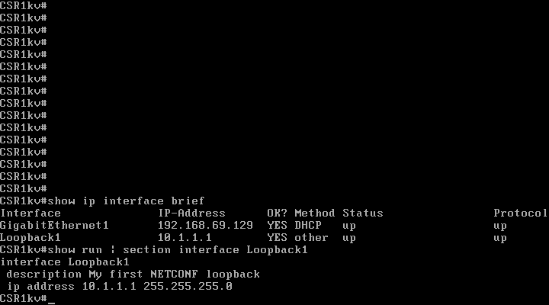
Screenshot 33: On the router, show ip interface brief lists Loopback1 at 10.1.1.1, and show run | section interface Loopback1 shows its description and address.
Close configuration window

Attempt to create a new loopback interface with the same IPv4 address.
      - Create a new variable called netconf_newloop. It will hold a configuration that creates a new loopback 2 interface but with the same IPv4 address as on loopback 1: 10.1.1.1 /24. At the router CLI, this would create an error because of the attempt to assign a duplicate IP address to an interface.
netconf_newloop = """
<config>
<native xmlns="http://cisco.com/ns/yang/Cisco-IOS-XE-native">
<interface>
<Loopback>
<name>2</name>
<description>My second NETCONF loopback</description>
<ip>
<address>
<primary>
<address>10.1.1.1</address>
<mask>255.255.255.0</mask>
</primary>
</address>
</ip>
</Loopback>
</interface>
</native>
</config>
"""
      - Add the following edit_config() function to your ncclient_netconf.py to send the new loopback configuration to the CSR1kv. You do not need a print statement for this step.
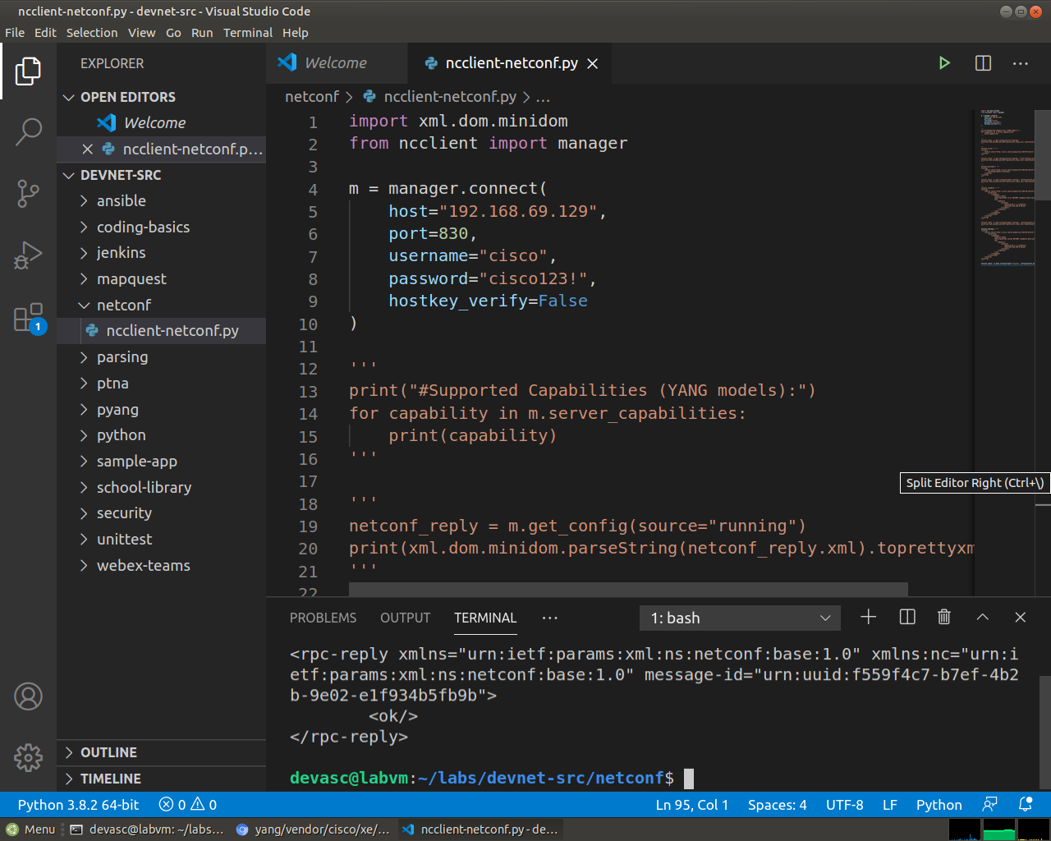
Screenshot 34: netconf_newloop, which tries to give Loopback2 the same address, 10.1.1.1.
netconf_reply = m.edit_config(target="running", config=netconf_newloop)
      - Save and run the program. You should get error output similar to the following with the RPCError message Device refused one or more commands.
devasc@labvm:~/labs/devnet-src/netconf$ python3 ncclient-netconf.py
Traceback (most recent call last):
File "ncclient-netconf.py", line 80, in <module>
netconf_reply = m.edit_config(target="running", config=netconf_newloop)
File "/home/devasc/.local/lib/python3.8/site-packages/ncclient/manager.py", line 231, in execute
return cls(self._session,
File "/home/devasc/.local/lib/python3.8/site-packages/ncclient/operations/edit.py", line 69, in request
return self._request(node)
File "/home/devasc/.local/lib/python3.8/site-packages/ncclient/operations/rpc.py", line 348, in _request
raise self._reply.error
ncclient.operations.rpc.RPCError: inconsistent value: Device refused one or more commands
devasc@labvm:~/labs/devnet-src/netconf$
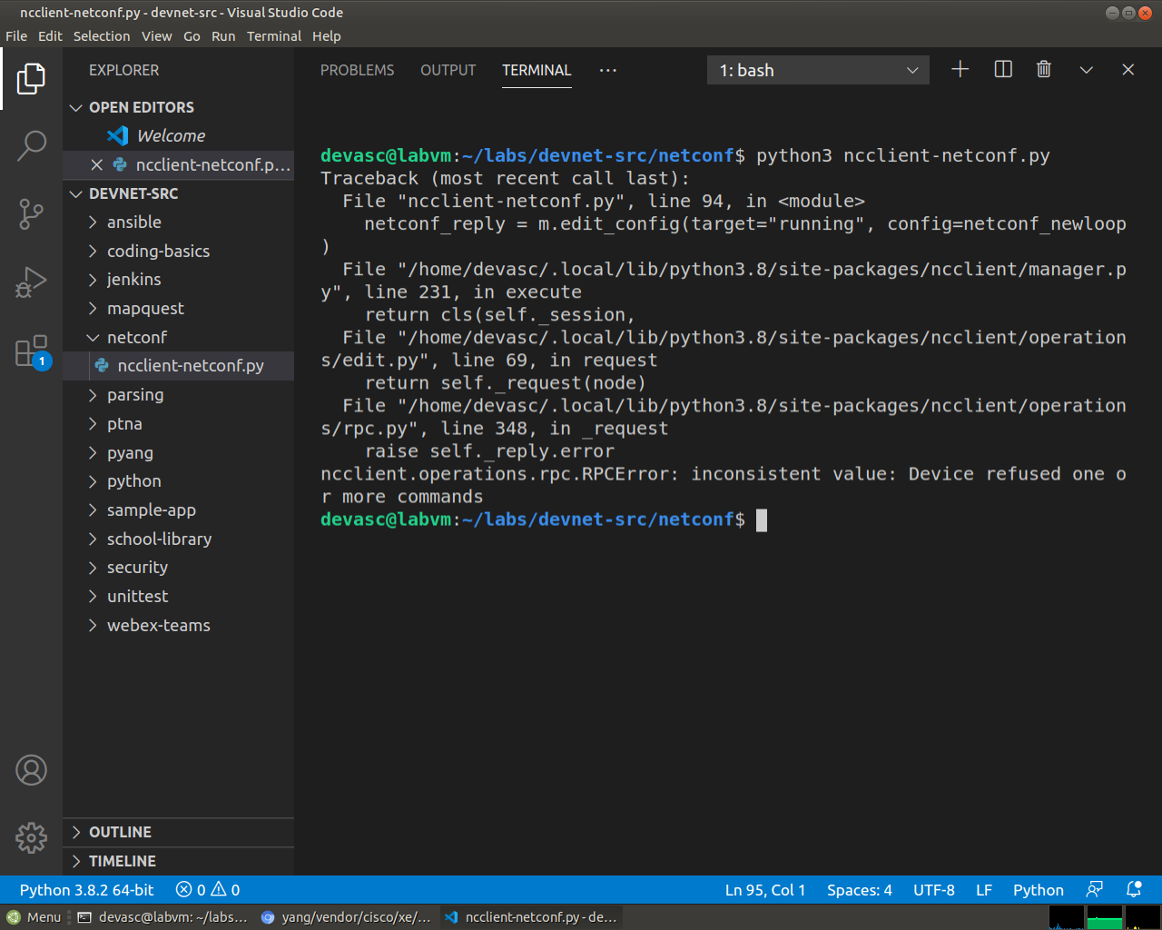
Screenshot 35: The run ends with RPCError: inconsistent value: Device refused one or more commands.
      - NETCONF will not apply any of the configuration that is sent if one or more commands are rejected. To verify this, enter the show ip interface brief command on R1. Notice that your new interface was not created.
Open configuration window
CSR1kv# show ip interface brief
Interface IP-Address OK? Method Status Protocol
GigabitEthernet1 192.168.56.101 YES DHCP up up
Loopback1 10.1.1.1 YES other up up
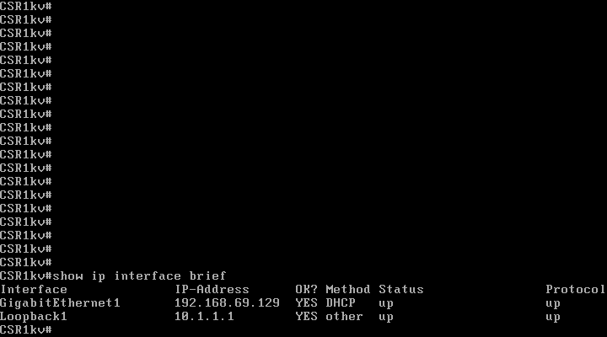
Screenshot 36: show ip interface brief still lists only Loopback1, so none of the Loopback2 configuration was applied.
Close configuration window

Challenge: Modify the Program Used in This Lab
The following is the complete program that was created in this lab with none of the code commented out so you can run the script without error. Your script may look different. Practice your Python skills by modifying the program to send different verification and configuration commands.
from ncclient import manager
import xml.dom.minidom

m = manager.connect(
host="192.168.56.101",
port=830,
username="cisco",
password="cisco123!",
hostkey_verify=False
)

print("#Supported Capabilities (YANG models):")
for capability in m.server_capabilities:
print(capability)

netconf_reply = m.get_config(source="running")
print(xml.dom.minidom.parseString(netconf_reply.xml).toprettyxml())

netconf_filter = """
<filter>
<native xmlns="http://cisco.com/ns/yang/Cisco-IOS-XE-native" />
</filter>
"""
netconf_reply = m.get_config(source="running", filter=netconf_filter)
print(xml.dom.minidom.parseString(netconf_reply.xml).toprettyxml())

netconf_hostname = """
<config>
<native xmlns="http://cisco.com/ns/yang/Cisco-IOS-XE-native">
<hostname>CSR1kv</hostname>
</native>
</config>
"""
netconf_reply = m.edit_config(target="running", config=netconf_hostname)
print(xml.dom.minidom.parseString(netconf_reply.xml).toprettyxml())

netconf_loopback = """
<config>
<native xmlns="http://cisco.com/ns/yang/Cisco-IOS-XE-native">
<interface>
<Loopback>
<name>1</name>
<description>My NETCONF loopback</description>
<ip>
<address>
<primary>
<address>10.1.1.1</address>
<mask>255.255.255.0</mask>
</primary>
</address>
</ip>
</Loopback>
</interface>
</native>
</config>
"""
netconf_reply = m.edit_config(target="running", config=netconf_loopback)
print(xml.dom.minidom.parseString(netconf_reply.xml).toprettyxml())

netconf_newloop = """
<config>
<native xmlns="http://cisco.com/ns/yang/Cisco-IOS-XE-native">
<interface>
<Loopback>
<name>2</name>
<description>My second NETCONF loopback</description>
<ip>
<address>
<primary>
<address>10.1.1.1</address>
<mask>255.255.255.0</mask>
</primary>
</address>
</ip>
</Loopback>
</interface>
</native>
</config>
"""
netconf_reply = m.edit_config(target="running", config=netconf_newloop)
To conclude, NETCONF over SSH on port 830 lets the DEVASC VM read and change the CSR1kv with XML, and ncclient hides the raw RPC messages behind a few Python lines. The router also refuses the whole change when one command is wrong, which is why Loopback2 never appeared. After the lab, the hostname was CSR1kv again and Loopback1 was removed, so the router has its original configuration.
End of document

